|  |  |  |
| --- | --- | --- |
| FINANCIAL RISK  ANALYSIS- LOAN  DEFAULT    SUBMITTED BY: KANUPRIYA MITTAL |  |  |

CONTENT:

1. Project Objective
2. Data Analysis
   1. Descriptive Data Analysis
   2. Exploratory Data Analysis
      1. Univariate Analysis
      2. Bivariate Analysis
3. Check for Integrity of Data
   1. Outlier Detection
   2. Missing Value Detection
4. Creating The Default variable
5. Missing Value Treatment

4.1 Imputation using MICE

1. Creation Of New Ratios for Raw Data set
   1. Ratios for profitability
   2. Ratios for Size
   3. Ratios for Liquidity
   4. Ratios for Leverage
2. Outliers Treatment
   1. Capping the Outliers
3. Multicollinearity Treatment
   1. Creating a Logistic Model
   2. Using the VIF to remove highly correlated variables
   3. Using StepAIC to give the lowest AIC from specific variables
4. Selection of the Significant Variables For Model Building
   1. Using STEPAIC
5. Balancing the dataset
   1. Smote Method
6. Creating the Final Model using SMOTE dataset 11.1 Applying Logistic regression
7. Analysis Of the Coefficients of Logistic Model
8. Predictions + Confusion Matrix on the Developed dataset
9. Preparing the Validation Dataset
   1. Importing the validation set
   2. Descriptive analysis
   3. Imputing the Missing Values
   4. Creation of New ratios(variables same as the Developed dataset)
   5. Selecting the Final Significant variables for validation set
10. Predictions + Confusion Matrix on the Validation Dataset
11. Sorting and Deciling of the Validation Set
    1. Adding The probability of default in our validation set
    2. Sorting in descending order by Probability of Default
    3. Creating deciles
       1. In the range form
       2. In the Ranking Form

# 1. PROJECT OBJECTIVE

Loan Defaults has a huge importance for Banks. Providing loans is the source of income for banks and if the Borrower fails to return back the loan money with interest, it’s a loss to the Bank. Banks want to minimize the loss this risk. Hence, we need a model that could predict it for the banks about the chances of Default. Default on loans is a crucial problem for any bank and managing this risk would come through a solution of being able to predict. So, we are supposed to create a predictive model which would model the past data provided by a bank and predict on an unseen future set of data.

Financial Risk Analysis is done in this project to alleviate the risk of losses to Banks.

# 2. DATA ANALYSIS

It is a culmination of Descriptive and Exploratory Data Analysis. It is done to understand the basic data structure as well as to visualize the dataset before performing any modelling. It checks for the relationship between the variables through the use of graphs. And also gives the summary and the class of each variable.

## 2.1 DESCRIPTIVE DATA ANALYSIS

The descriptive analysis tells about the basic structure of our dataset.

Structure of dataset:

str(data)

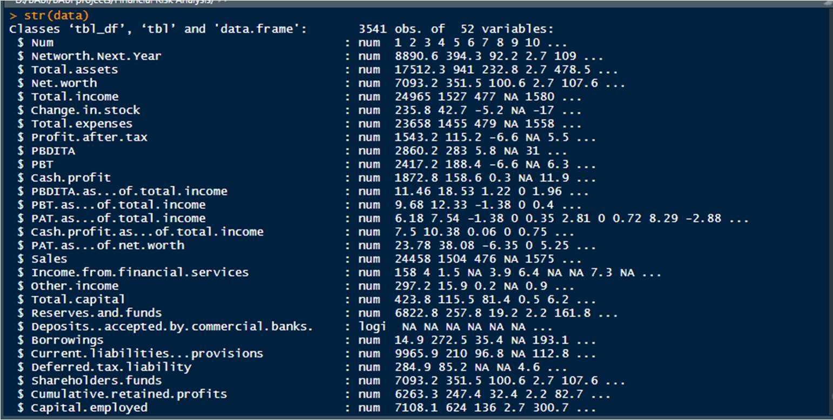

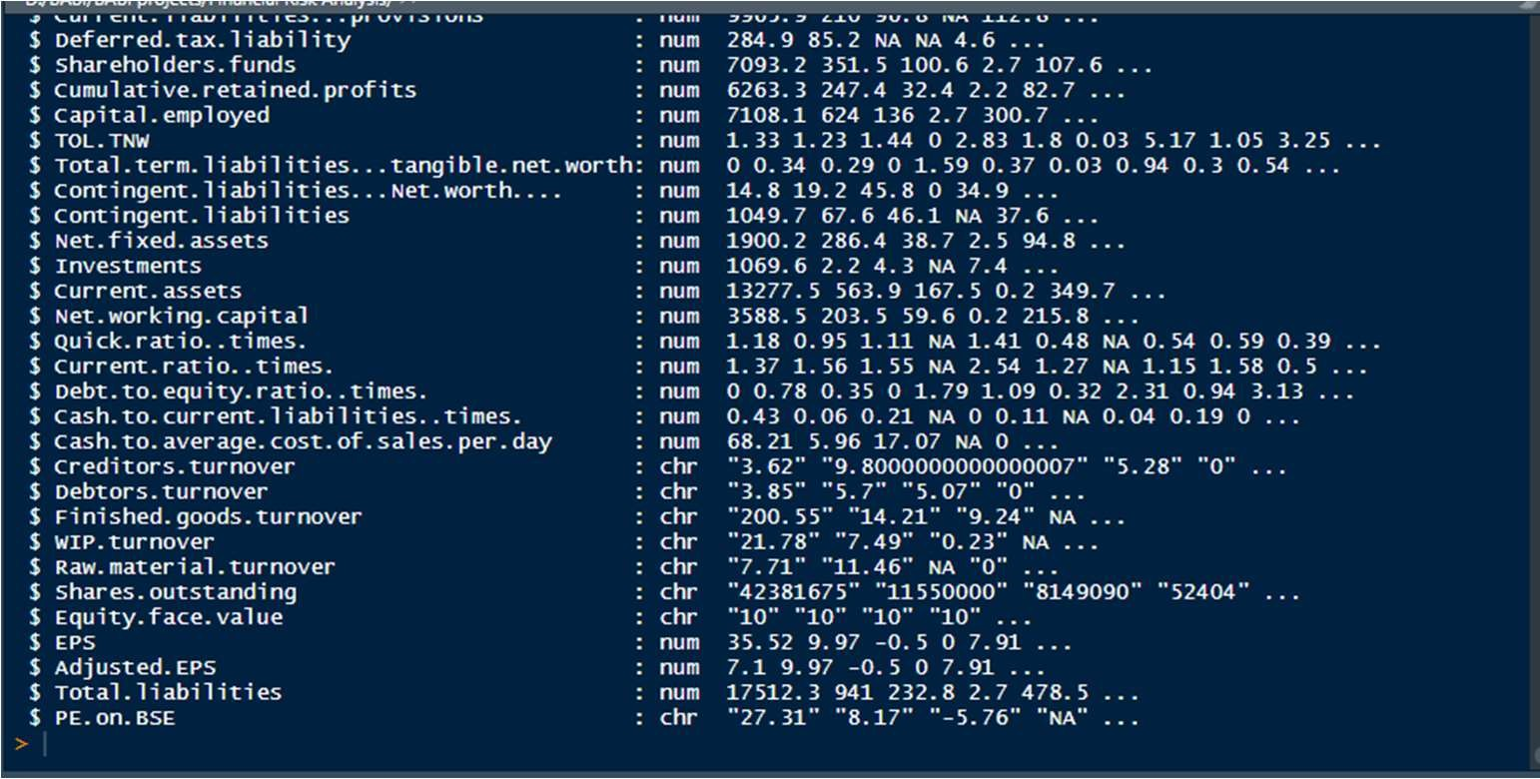

Dim: Gives the dimensions of the dataset

dim(data)

[1] 3541 52

Head: Give the first 10 records from the data

head(data,10)

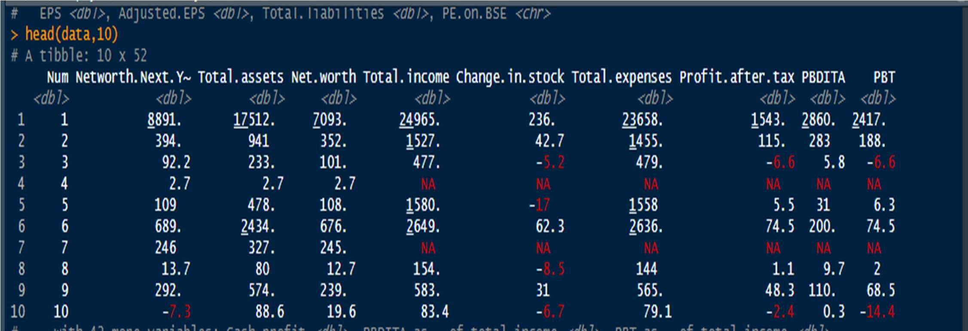

Tail: Gives the last 10 records from the data

tail(data,10)

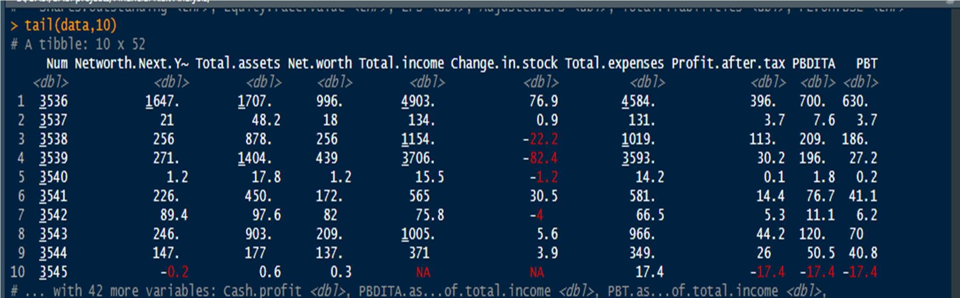

Names: Gives the names of all the variables. names(data)

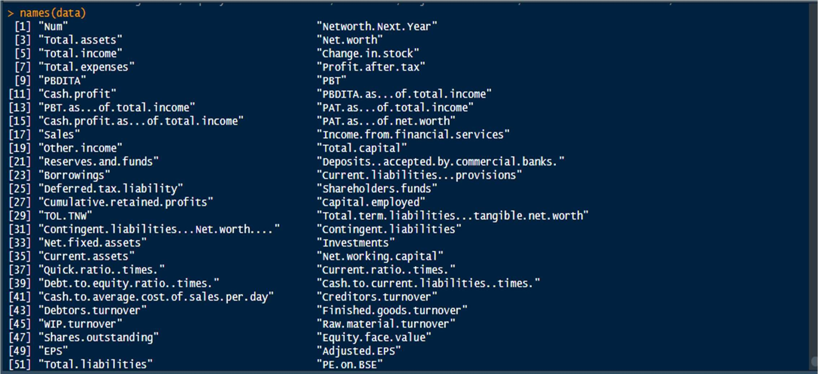

## 2.2 EXPLORATORY DATA ANALYSIS

Here we are going to explore the Variables by two methods: By CENTRAL TENDENCIES and by GRAPHS.

➔ Through Central Measure( MEAN, MEDIANS, MODE)

Summary of Dataset: summary(data)

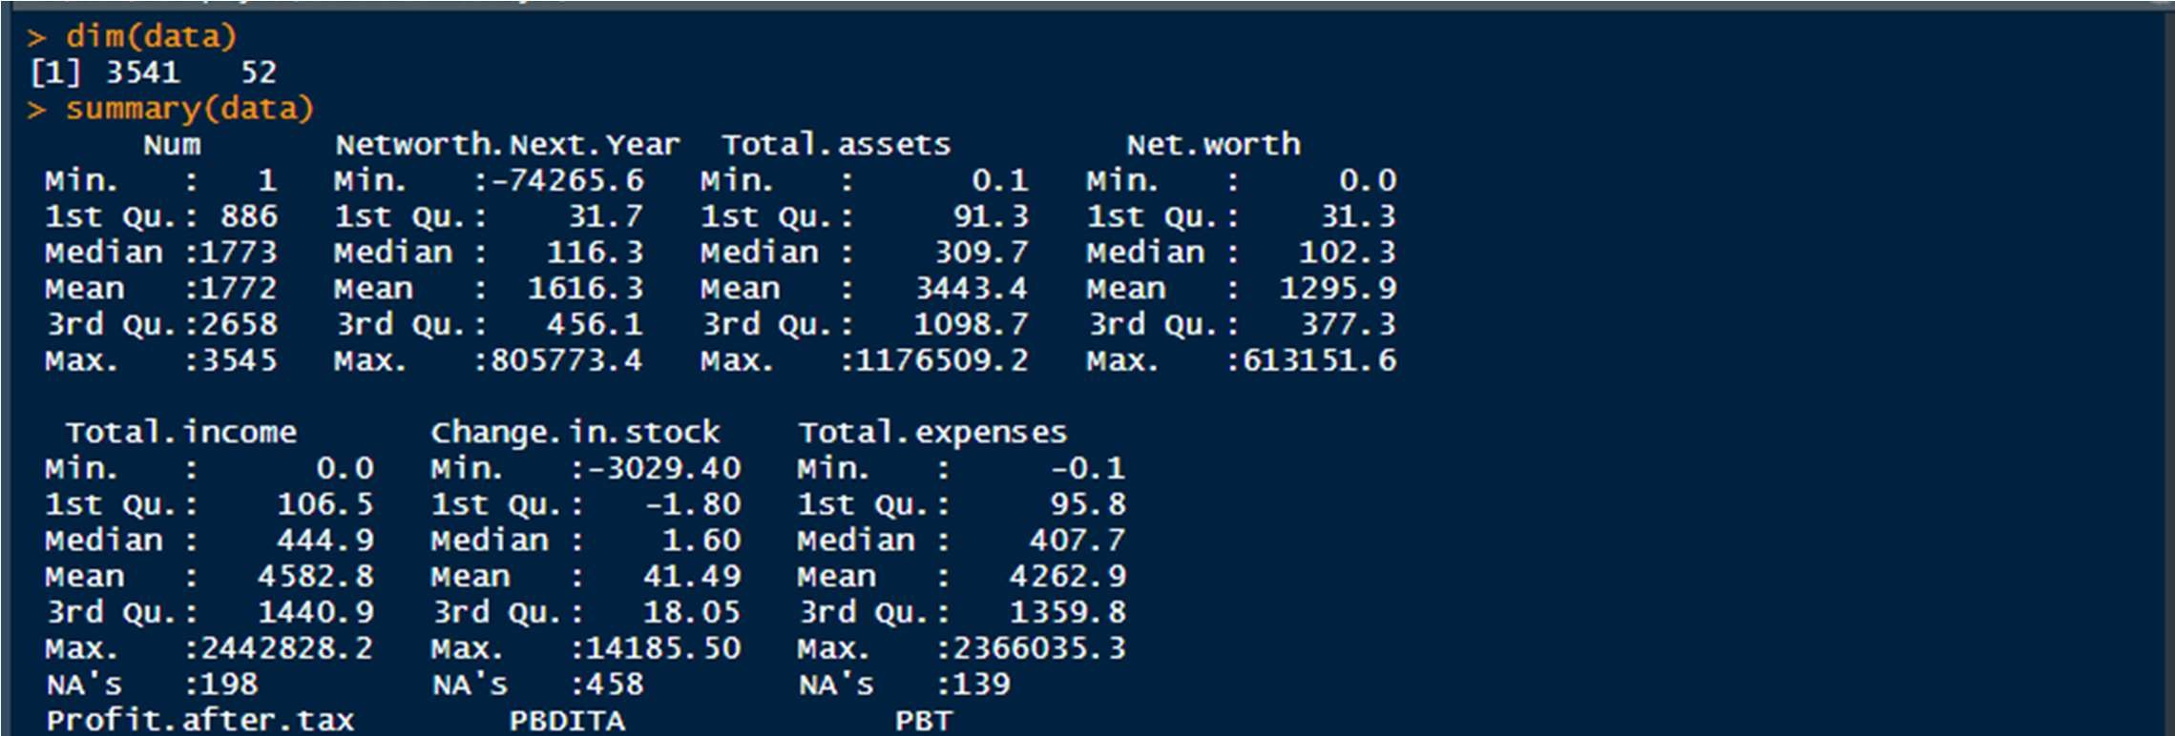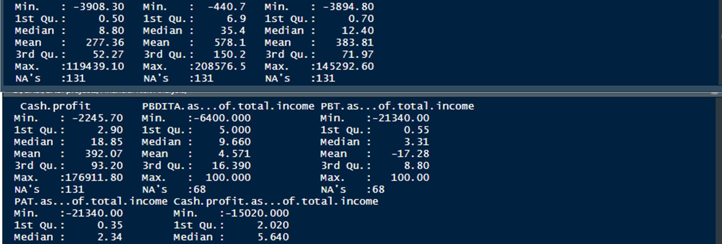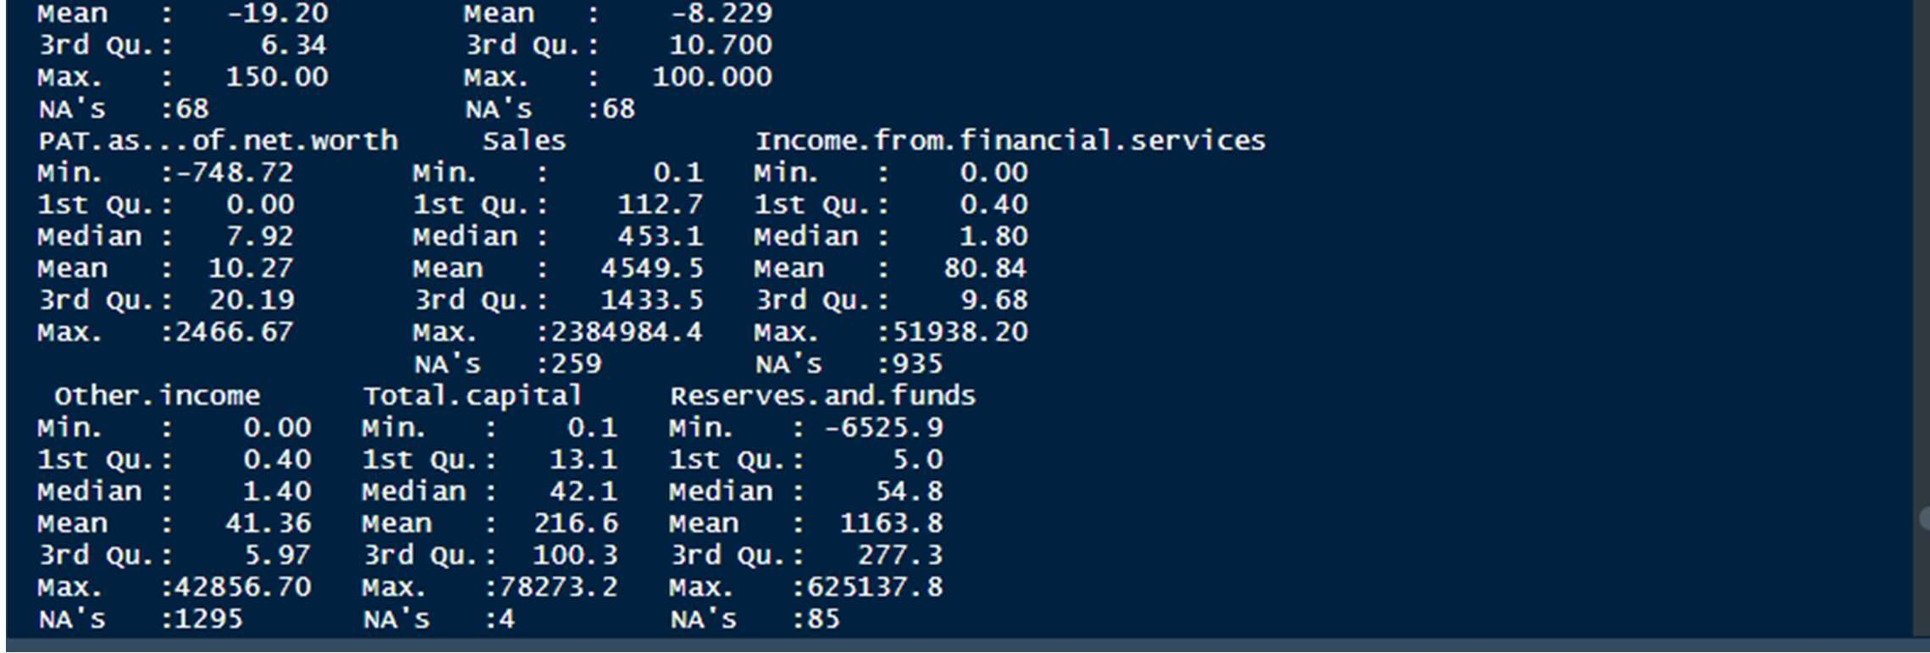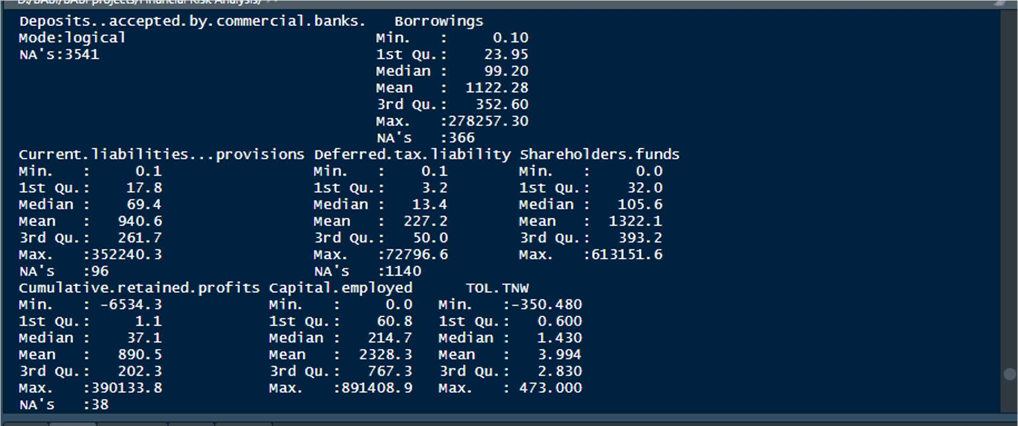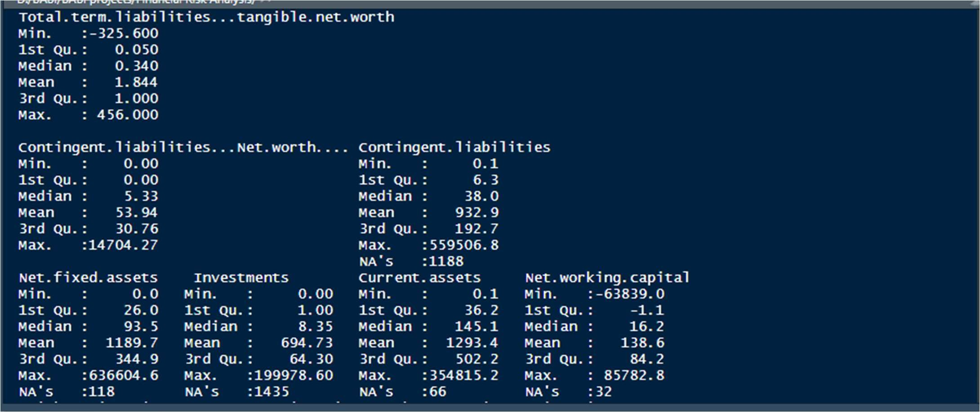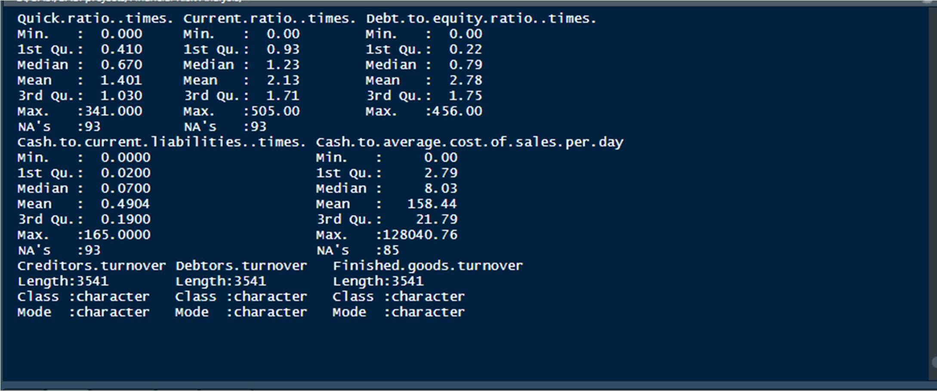

### ➔ Through Graphical Representaion

#### 2.2.1 UNIVARIATE ANALYSIS

Done for both categorical and continuous variables. Must be numeric for histogram plotting. hist(data[2])

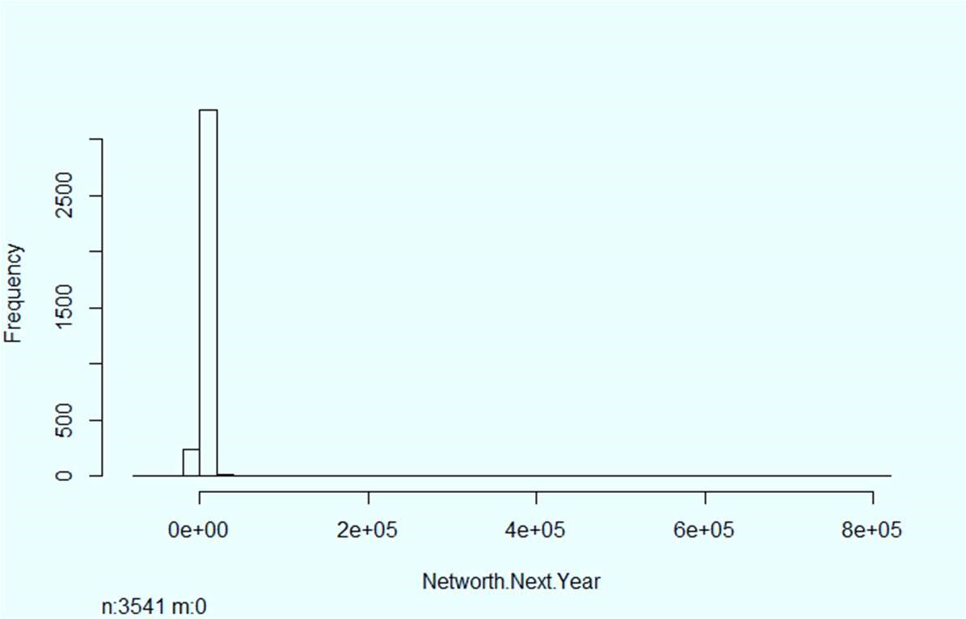

hist(data[1:12])

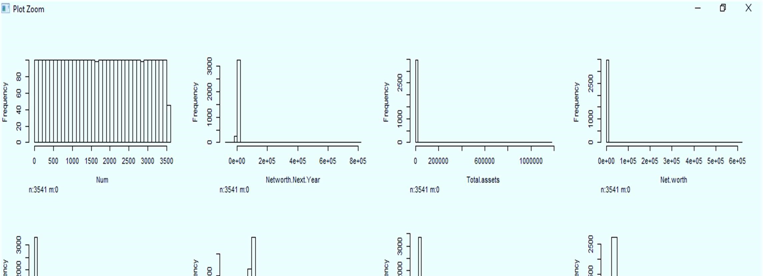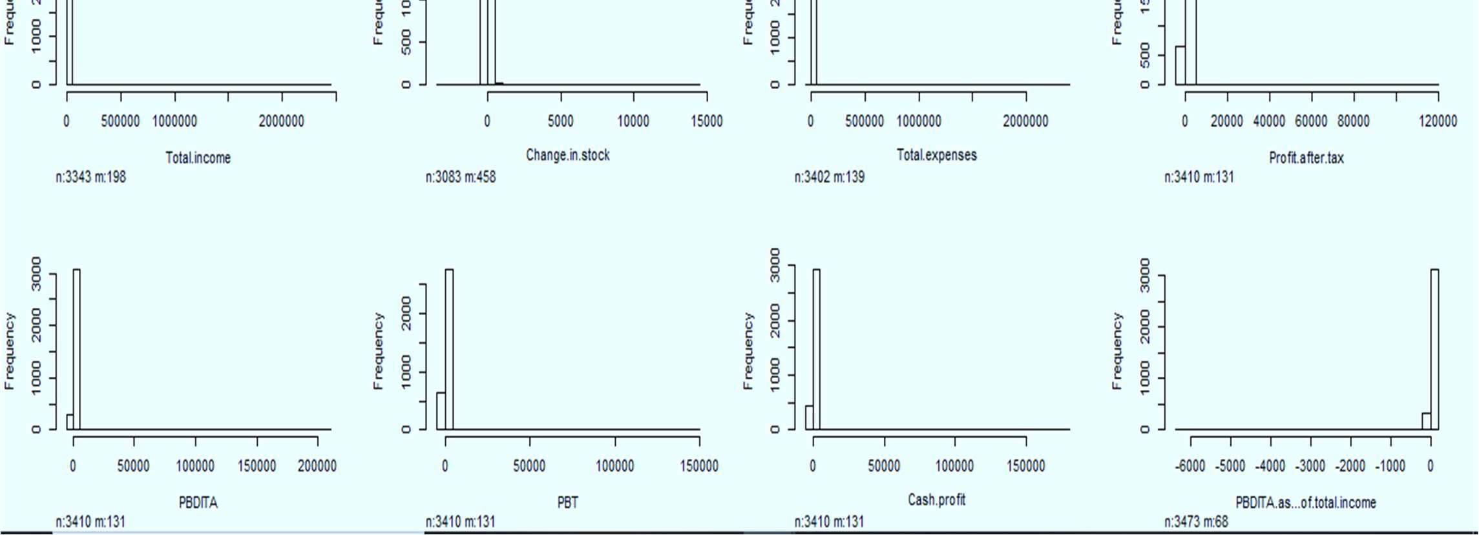

hist(data[13:24])

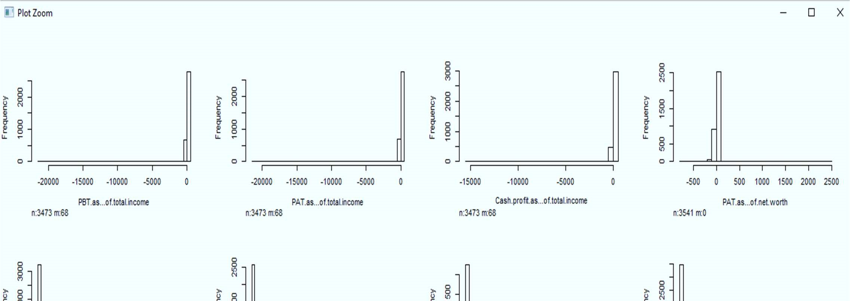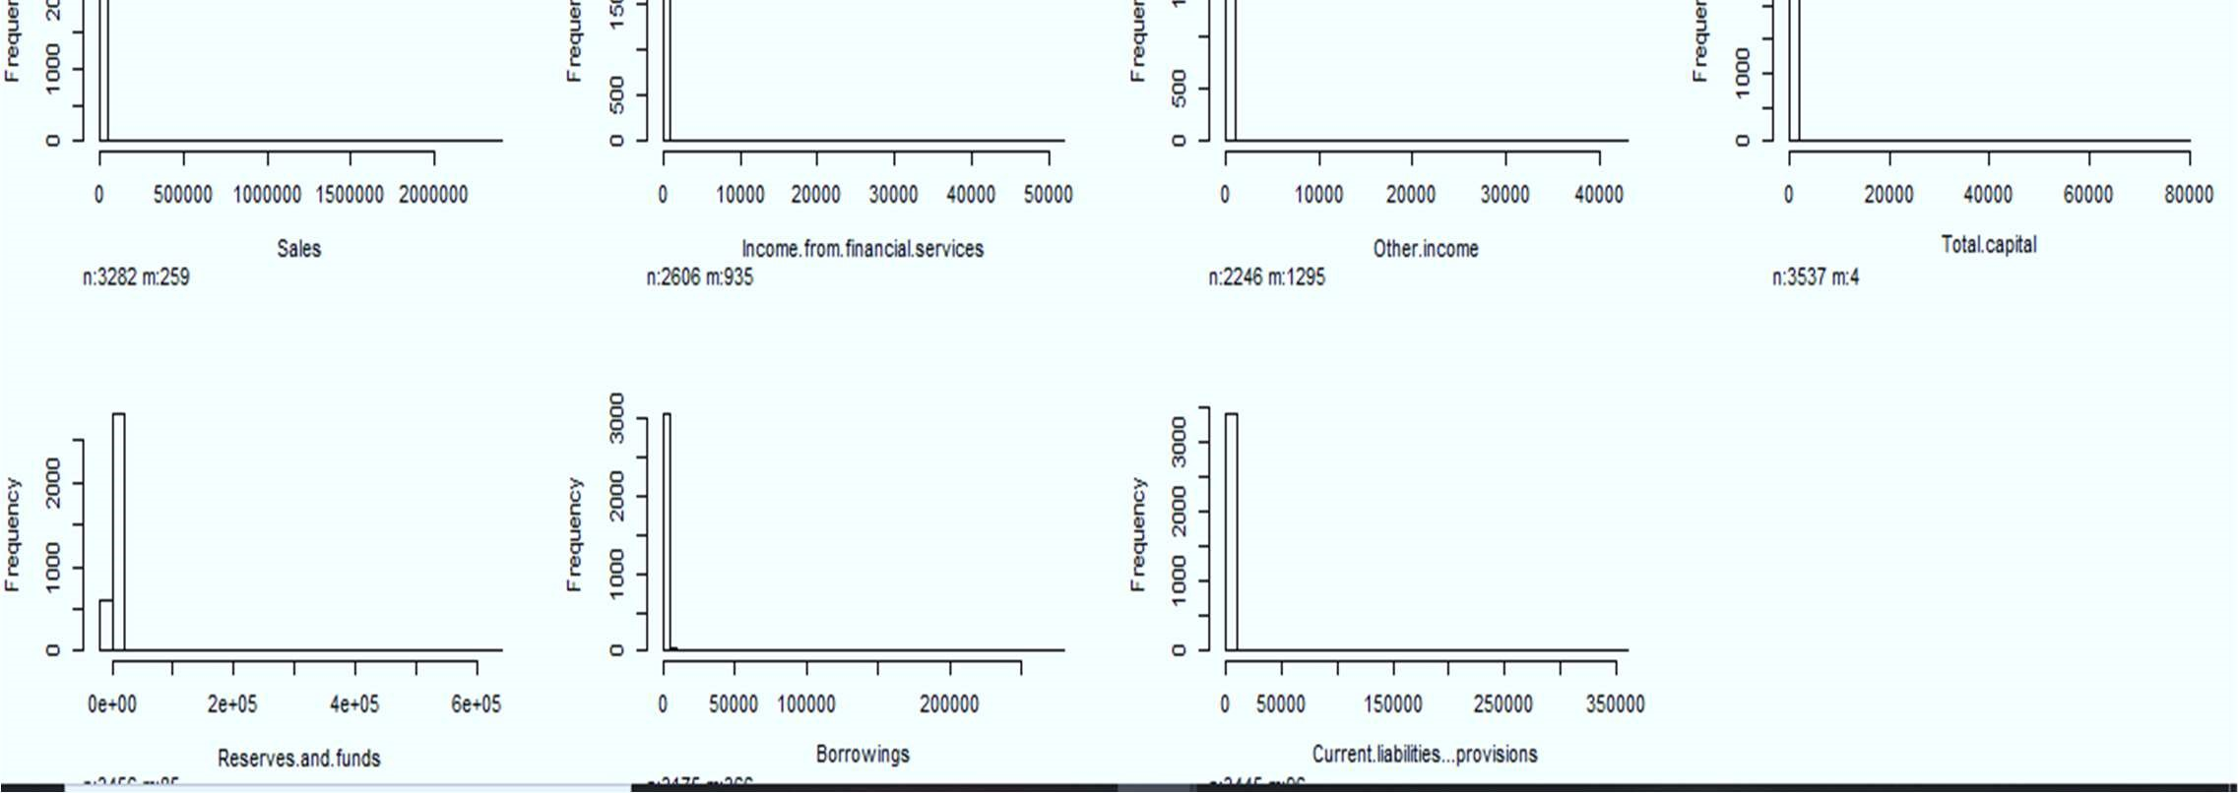

plot(data[,42]) : Creditors Turnover

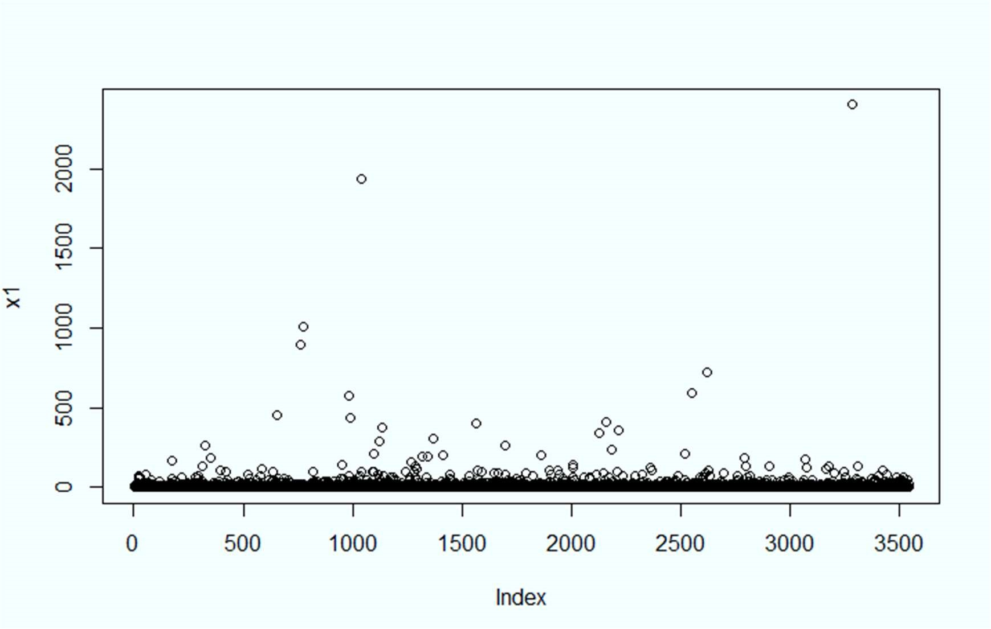

#### 2.2.2 BIVARIATE ANALYSIS

We can use both LINE and SCATTER Plots for Bivariate A

# Total Assets vs Cash Profit ggplot(data) + aes(x = `Total assets`, y = `Cash profit`) + geom_line(size = 1L, colour = "#0c4c8a") +

theme_minimal()

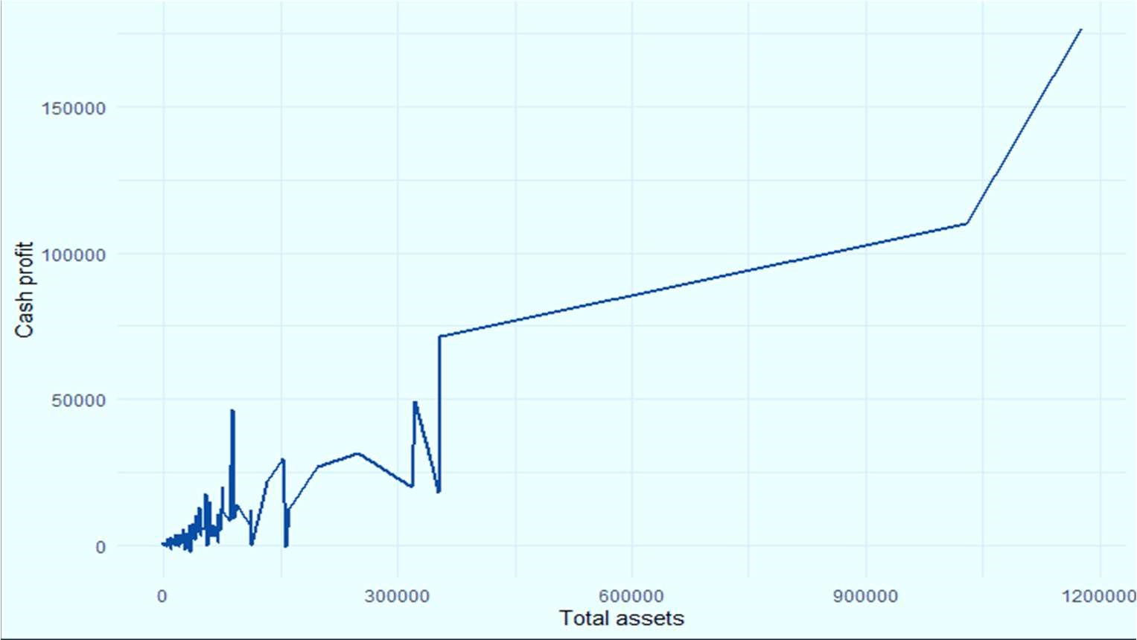

# Total Assets vs Net Working Capital ggplot(data) + aes(x = `Total assets`, y = `Net working capital`) + geom_line(size = 1L, colour = "#0c4c8a") +

theme_minimal()

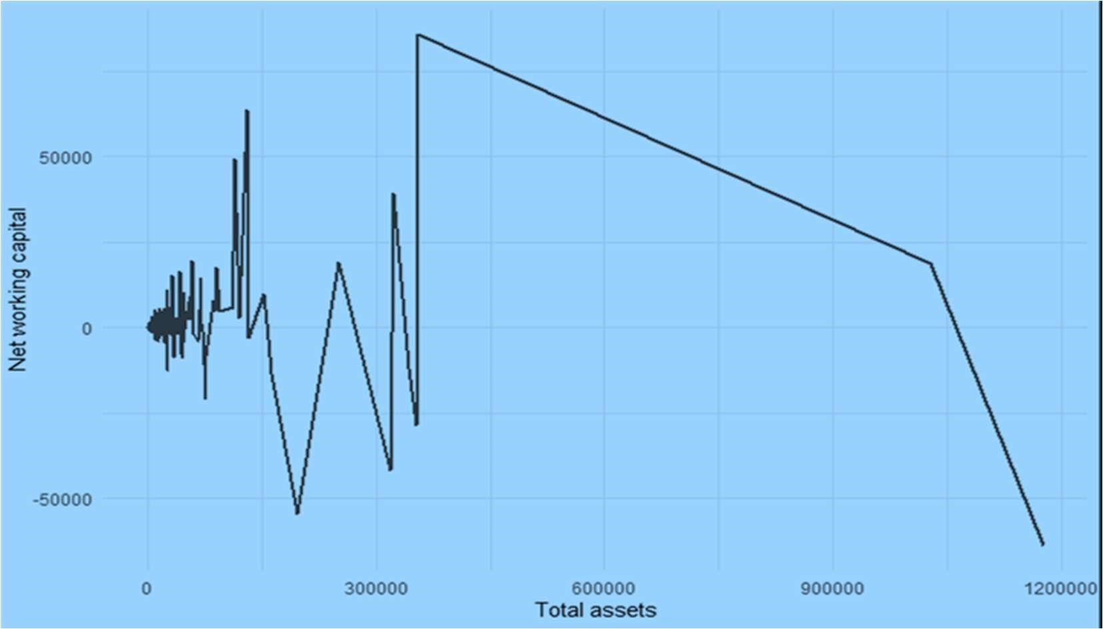

# Total Liabilities vs Borrowings ggplot(data) + aes(x = `Total liabilities`, y = Borrowings) + geom_line(size = 1L, colour = "#0c4c8a") +

theme_minimal()

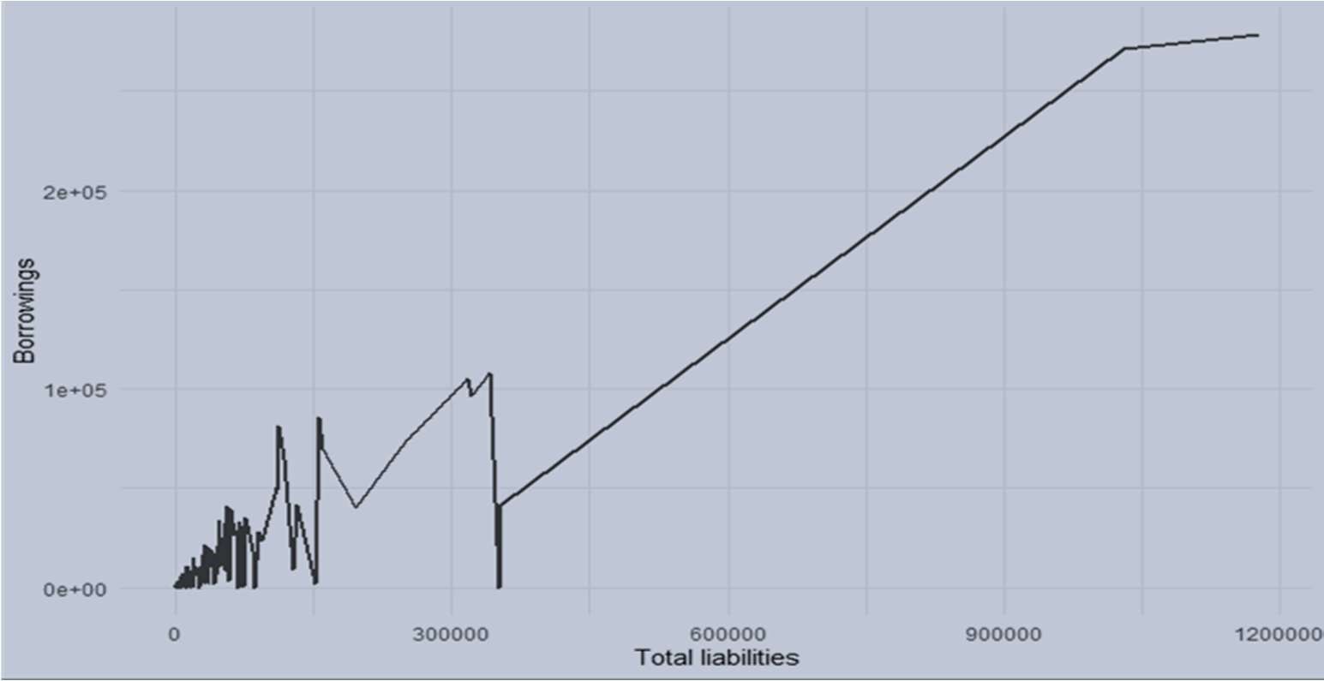

# Sales Vs Cumulative Retained Profits

ggplot(data) + aes(x = Sales, y = `Cumulative retained profits`) + geom_line(size = 1L, colour = "#0c4c8a") +

theme_minimal()

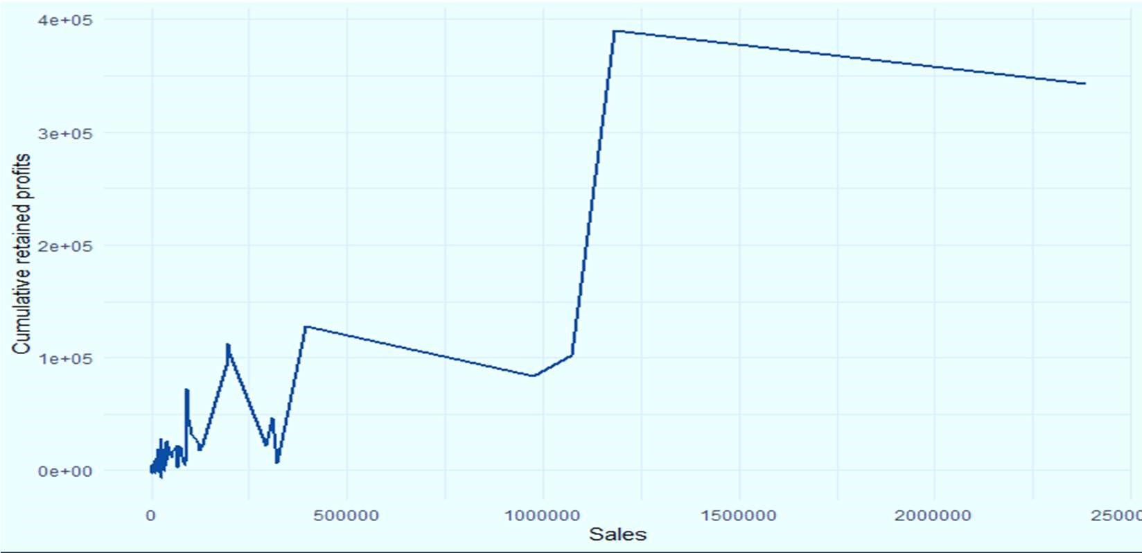

# Cash Profit vs Current Liabilities and provisions

ggplot(data) + aes(x = `Cash profit`, y = `Current liabilities & provisions`) + geom_line(size = 1.76, colour = "#0c4c8a") +

theme_minimal()

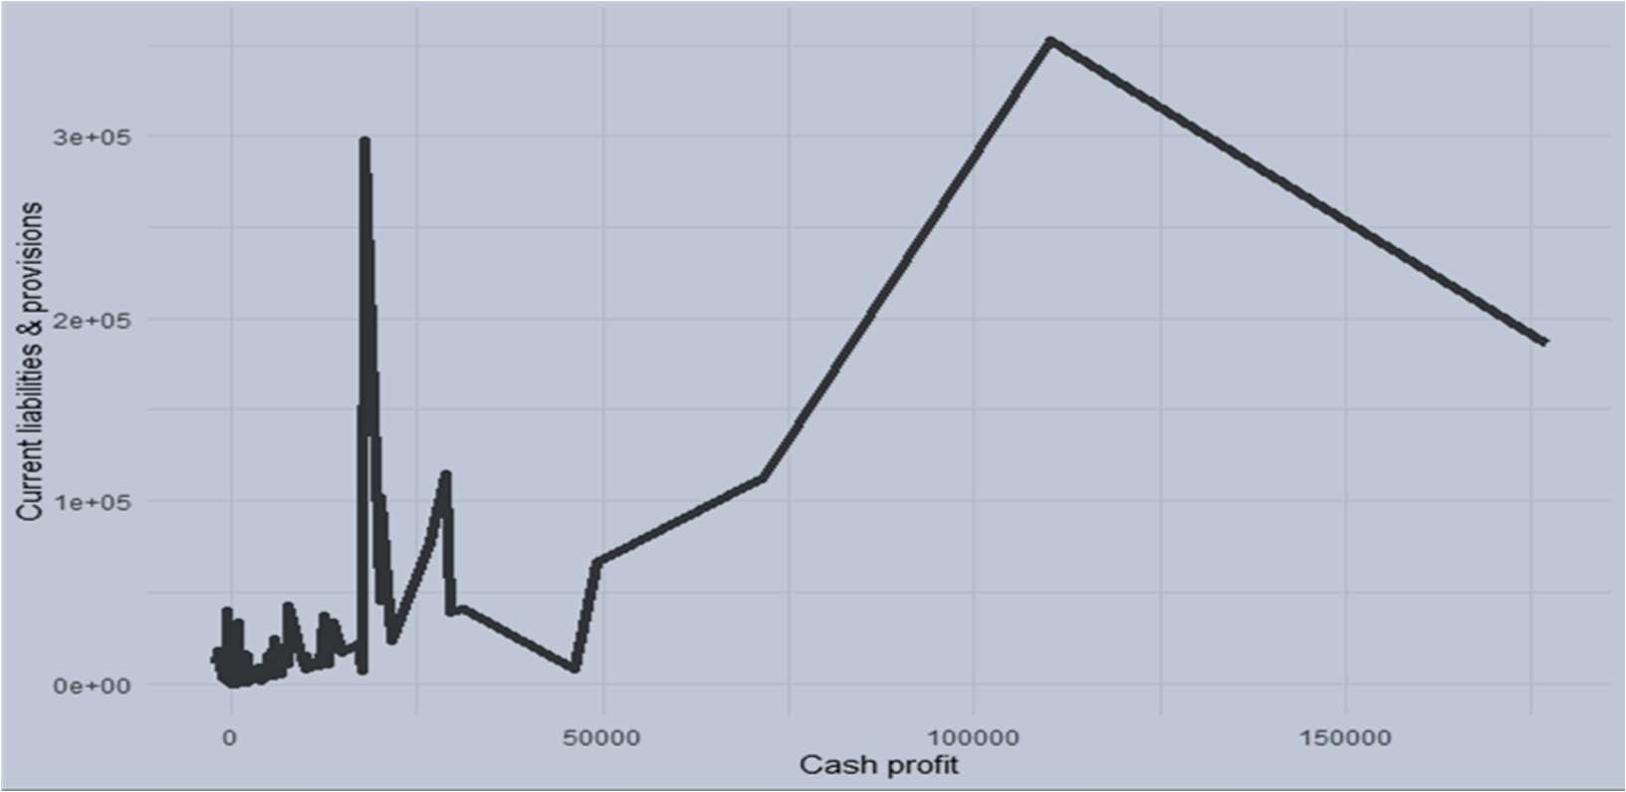

# Total Capital vs Total Liabilities

ggplot(data) + aes(x = `Total liabilities`, y = `Total capital`) +

geom_point(size = 2L, colour = "#0c4c8a") +

theme_minimal()

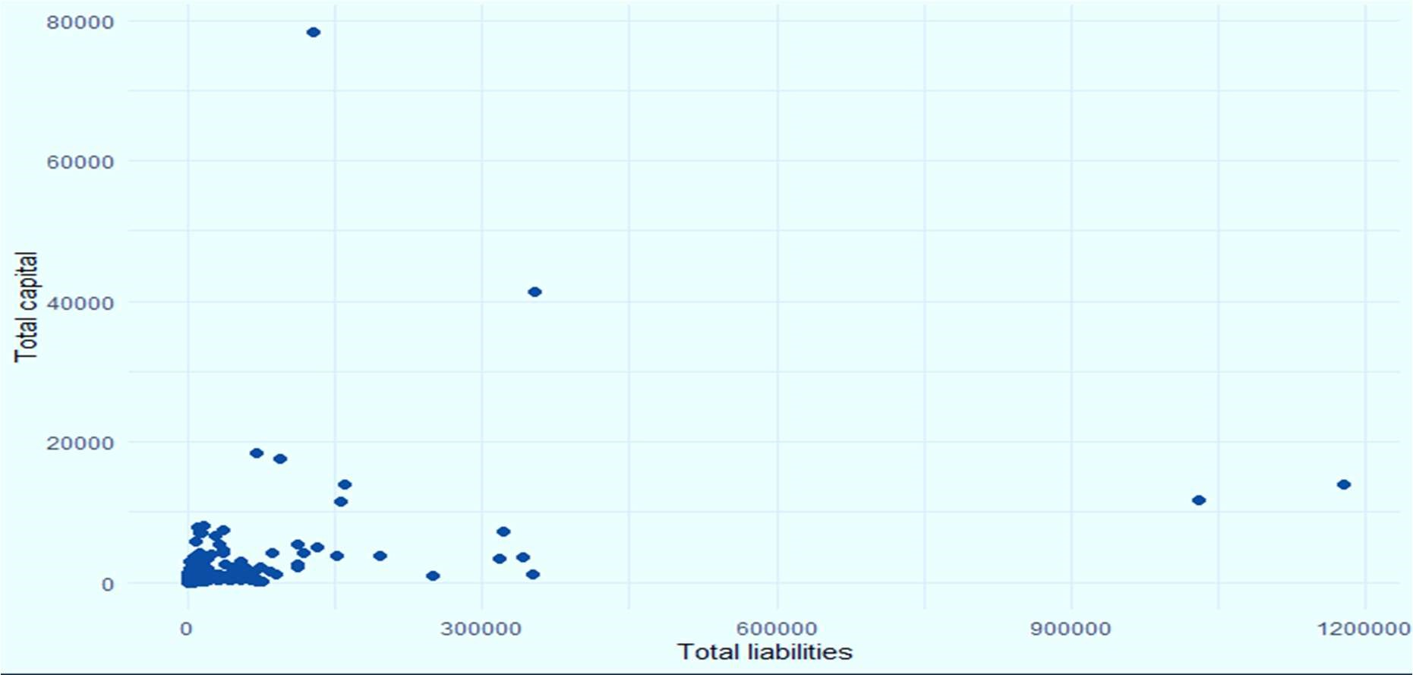

# Total Assests vs Total Liabilities

ggplot(data) + aes(x = Sales, y = `Total expenses`) + geom_line(size = 1.62, colour = "#0c4c8a") + theme_minimal()

plot(data$`Total assets`,data$`Total liabilities`)

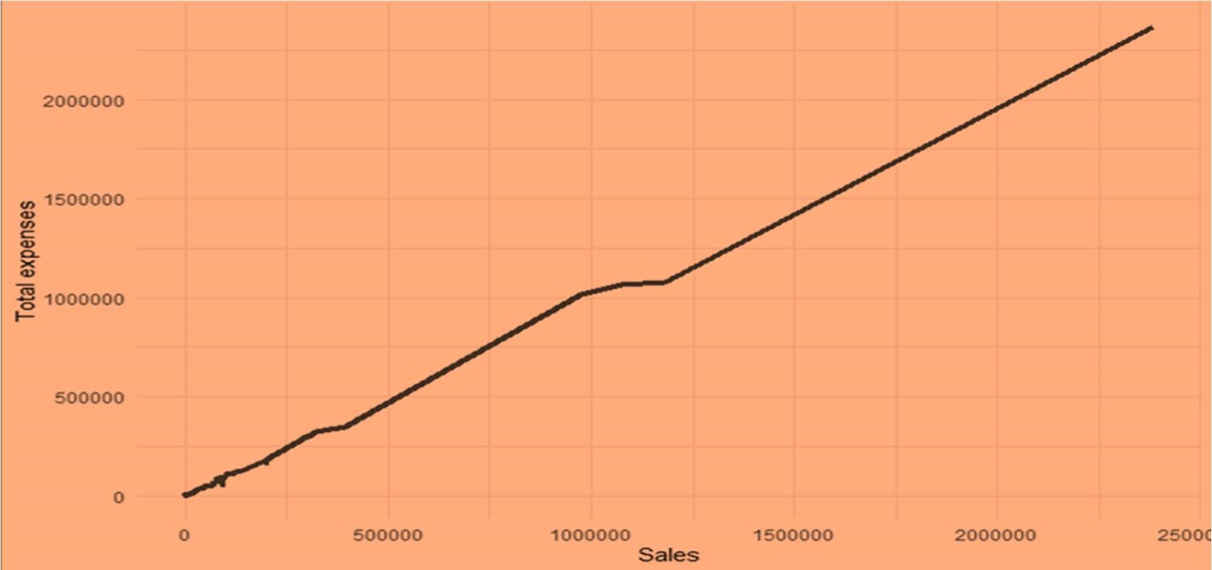

# 3. CHECK FOR INTEGRITY OF DATA

## 3.1 OUTLIER DETECTION

Depicts that there are outliers in our data. These plots are being made after seeing the correlation matrix and thus, figuring out which variables are to an extent related to each other and then we can visualize their relationship.

boxplot(data[,(1:26)])

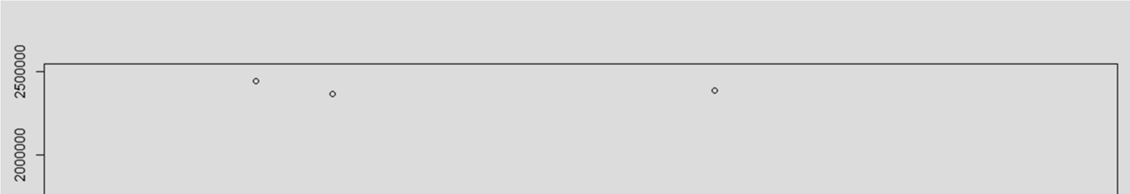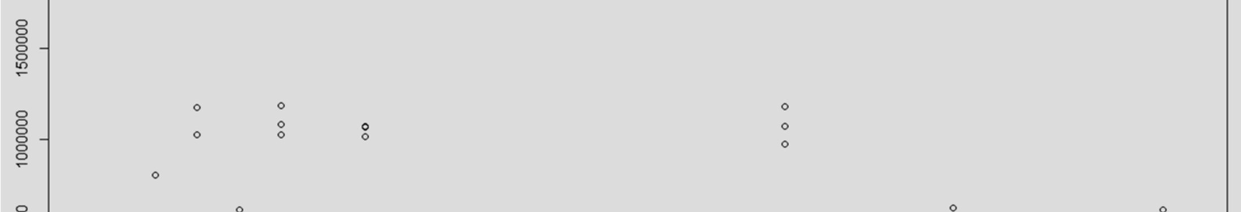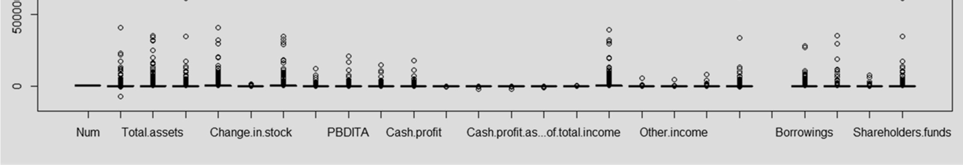

boxplot(data[,(27:41)])

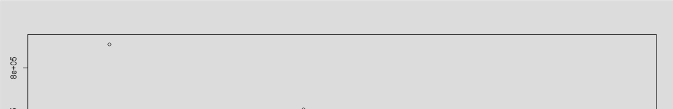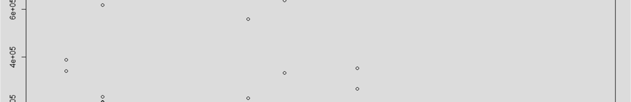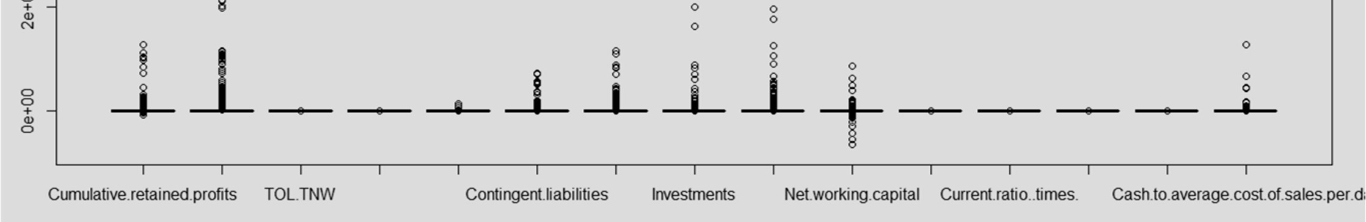

## 3.2 MISSING VALUE DETECTION

In R the missing values are coded by the symbol NA . To identify missings in your dataset the function is is.na()

colSums(is.na(data))

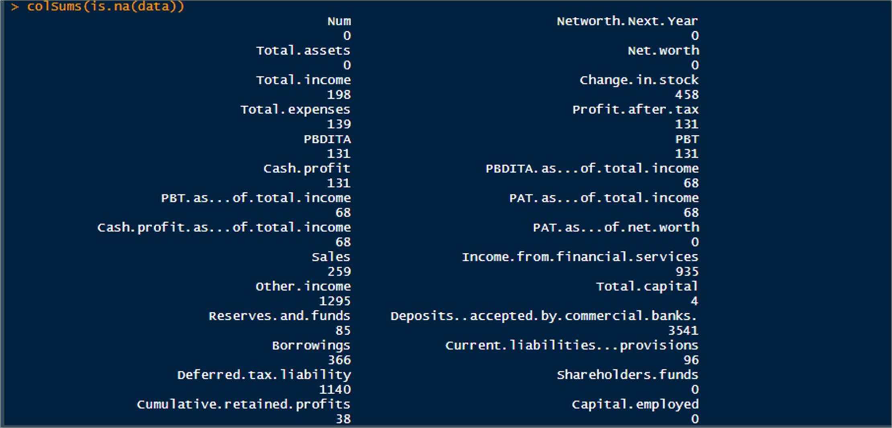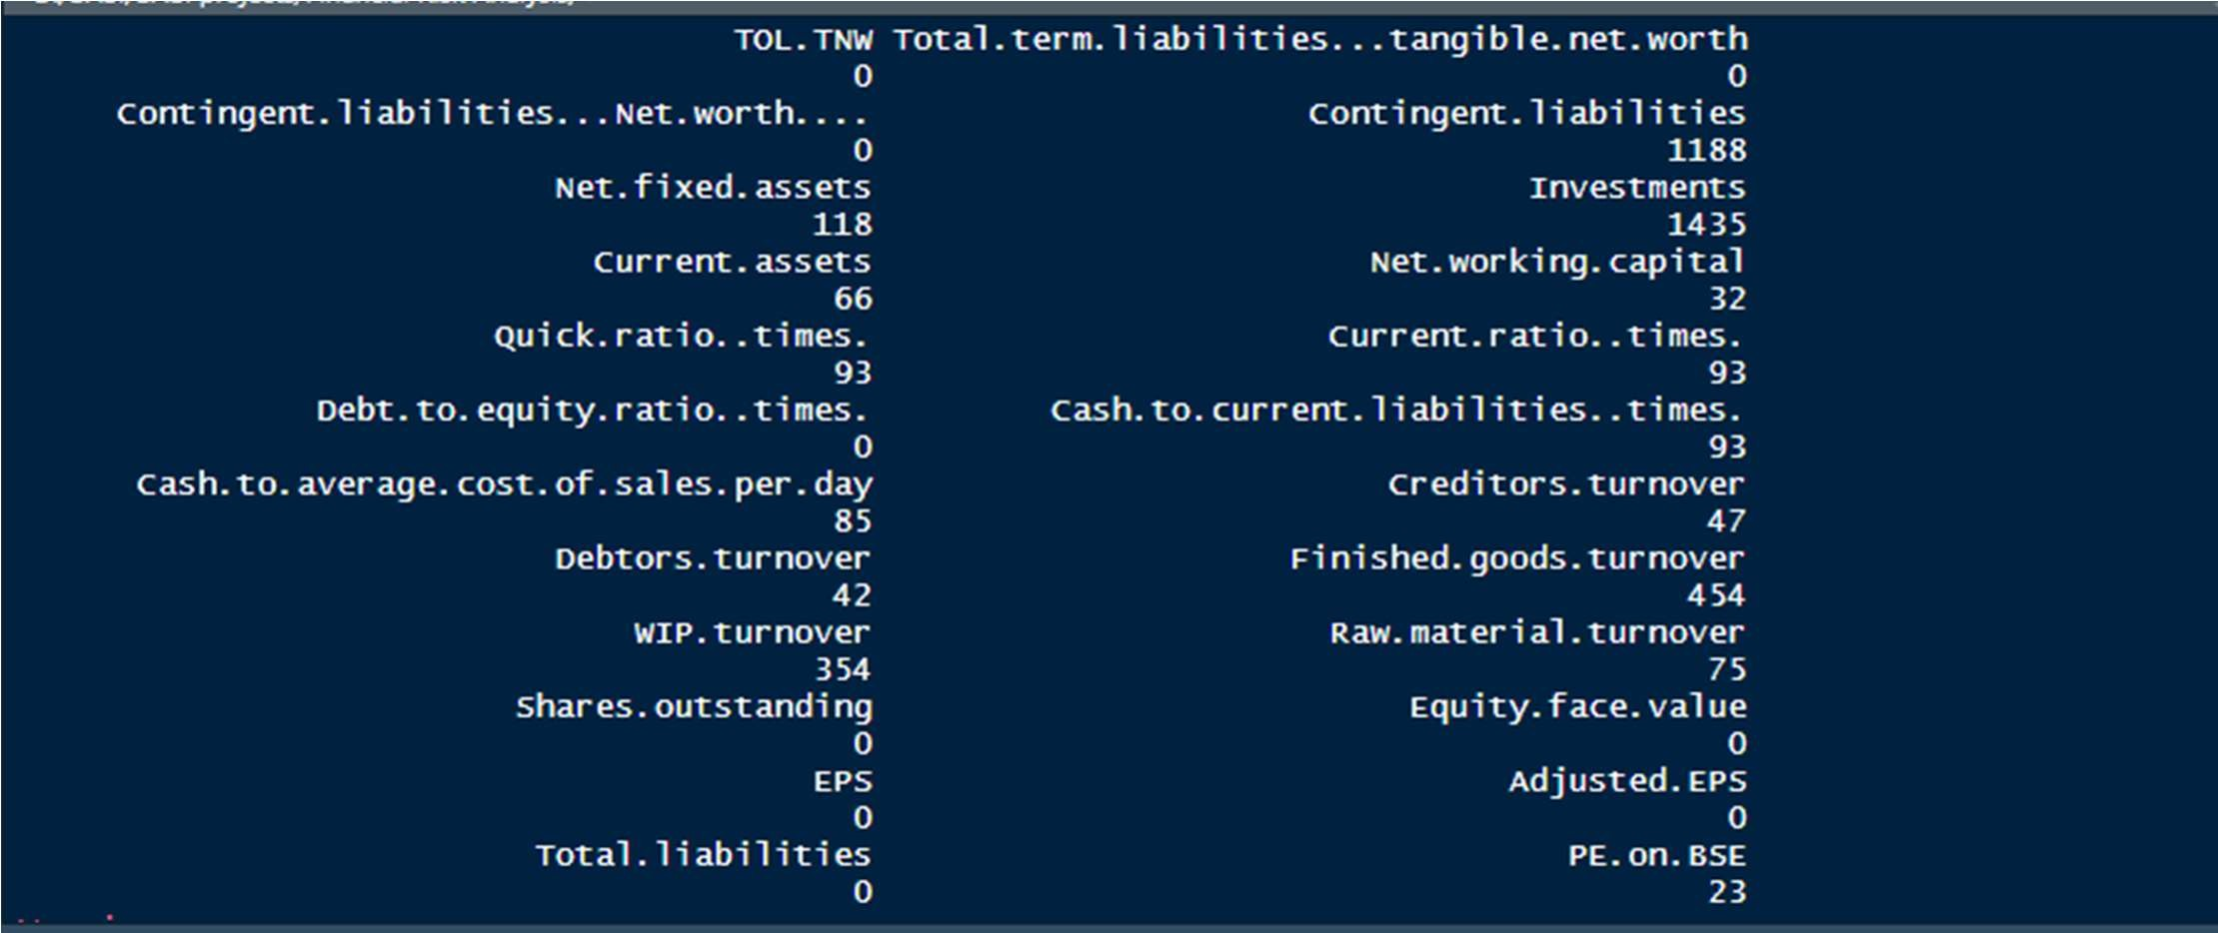

# 4. CREATING THE DEFAULT VARIABLE

The default variable (dependent Variable) has to be created by using the Networth Next Year variable of the dataset.

data$default= ifelse(`Networth Next Year`<0,1,0)

names(data)

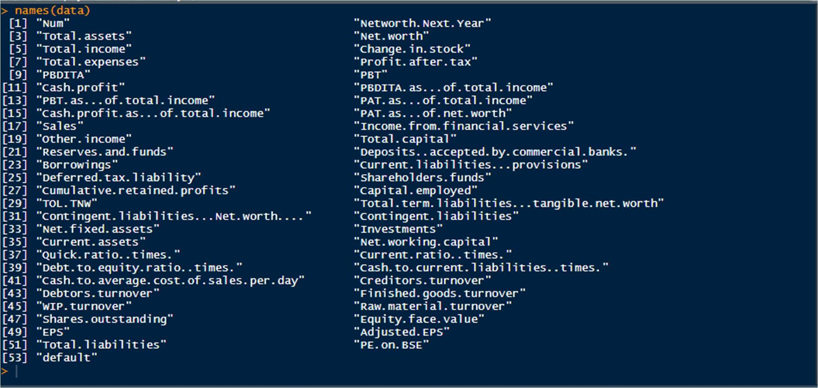

➔ REMOVING THE VARIABLES WITH HIGH MISSING VALUES AND SOME WHICH AREN'T AS IMPORTANT BY BANK'S PERSPECTIVE

VARIABLES REMOVED INITIALLY :

'Num', 'Networth Next Year', 'Change in Stock','Income from Financial Services',

'Other income','Deposits accepted by commercial banks','Investments',

'Creditors Turnover','Debtors Turnover','Finished Goods Turnover',

'Wip Turover' 'Raw Material Turnover','Equity Face Value','PE on BSE'

dataM= data[,-c(1,2,6,18,19,22,25,32,34,42:48,52)]

names(dataM)

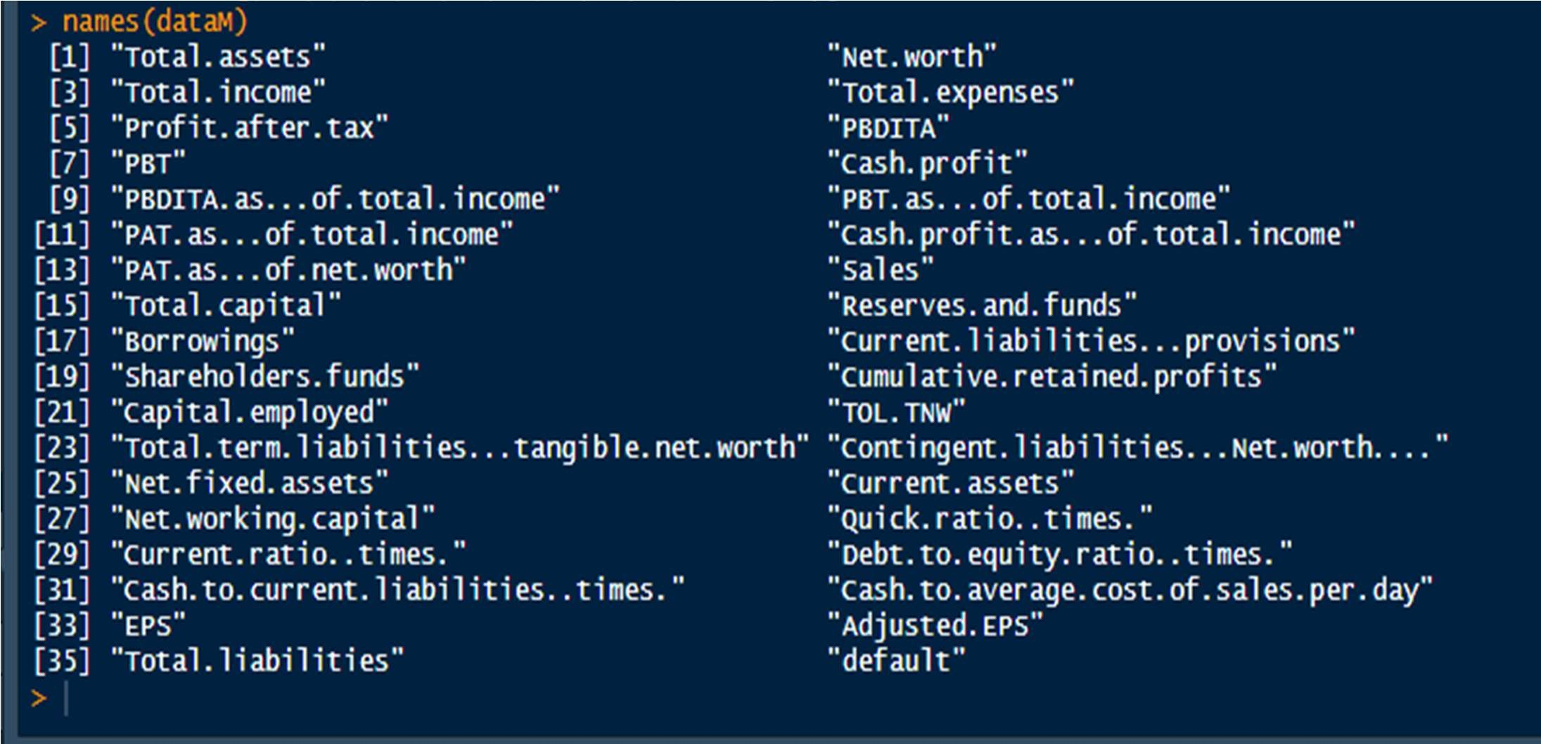

• TWO RATIOS CREATED IN ORDER FOR MICE TO WORK

Before Imputation using MICE we will have to remove the super correlated variables. On way is to create ratios with some other variables, before removing them so as to retain their importance in our dataset .

Sales and Total Income were super correlated with other Variables in our dataset. So, we made these 2 into ratios with other variables to reduce the collinearity.

1. Sales.per.TotalExpenses
2. Totalincome.per.TotalAssets

➔ Variables removed after these ratios creation are :

Total income and Total expenses

dataM=dataM[,-c(3,4)]

# 5. MISSING VALUE TREATMENT

5.1 IMPUTATION USING MICE

NAdata= mice(dataM,meth="pmm",seed=848,maxit = 5,m=5)

NAdata$imp

NAdata$loggedEvents

NAdata <- complete(NAdata)

colSums(is.na(NAdata))

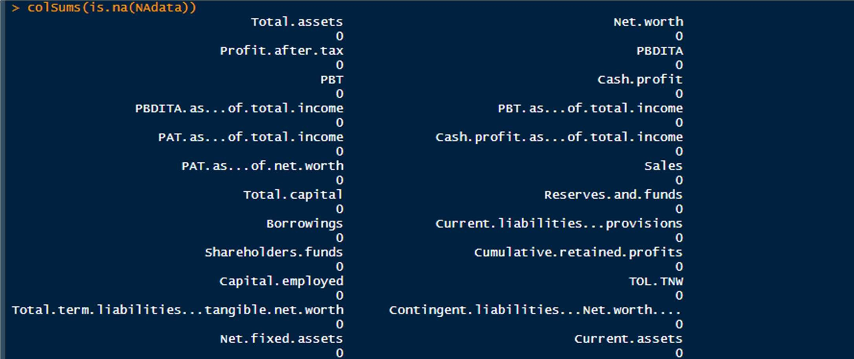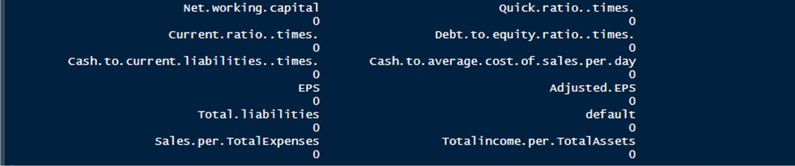

## 6. CREATION OF NEW RATIOS FOR RAW DATASET

### 6.1 Ratios For Profitability

CashProfit.per.TotalAssets

Cum.Profit.per.Sales

Sales.per.TotalAssets

Sales.per.CurentAssets

PBT.per.TotalCaptital

PAT.per.TotalAssets

PAT.per.Sales

PAT.per.TotalCapital

PAT.per.TotalAssets

PBT.per.TotalAssests

PBT.per.Sales

PBT.per.TotalCapital

PBDITA.per.Sales

### 6.2 Ratios For Size

ShareholderFunds.per.TotalAssets

Captialemployed.per.Networth

Reserves.per.TotalCapital

ShareholderFunds.per.TotalLiability ShareholderFunds.per.TotalCapital capitalEmp..per.ShareholderFunds NetFixedAssets.per.CurrentAssets NetFixedAssets.per.TotalAssets

### 6.3 Ratios For Leverage

Borrowings.per.TotalAssets

Borrowings.per.TotalLiabilities

Borrowings.per.TotalCapital

CurrentLiability.per.CurrentAssets

CurrentLiability.per.TotalAssets

### 6.4 Ratios For Liquidity

NetFixedAssets.per.TotalLiabilities

Cum.RetainedProfits.per.CurrentAssets

Networth.per.TotalLiabilities

Cum.RetainedProfit.per.TotalLiabilitie

PAT.per.CurrentLiability

CashProfit.per.CurrentLiabilities

TotalCapital.per.TotalLiabilities

TotalCapital.per.CurrentLiabilities

## 7. OUTLIERS TREATMENT

In this case, the outliers are not wrong values, so we cannot discard the outliers because they actually are true and correct values, however extreme they might be. So we will have to treat the outliers.

We will cap the outliers using flooring and ceiling technique.

### 7.1 CAPPING THE OUTLIERS

a=c(1:33,35:69)

for(val in a){ qnt<- quantile(outdata[,val],probs = c(0.25,0.75)) cap<- quantile(outdata[,val],probs = c(0.10,0.85))

h= 1.5*IQR(outdata[,val]) outdata[,val][outdata[,val]>(qnt[2]+h)]<- cap[2] outdata[,val][outdata[,val]<(qnt[1]-h)]<- cap[1]

}

#### boxplot(outdata)

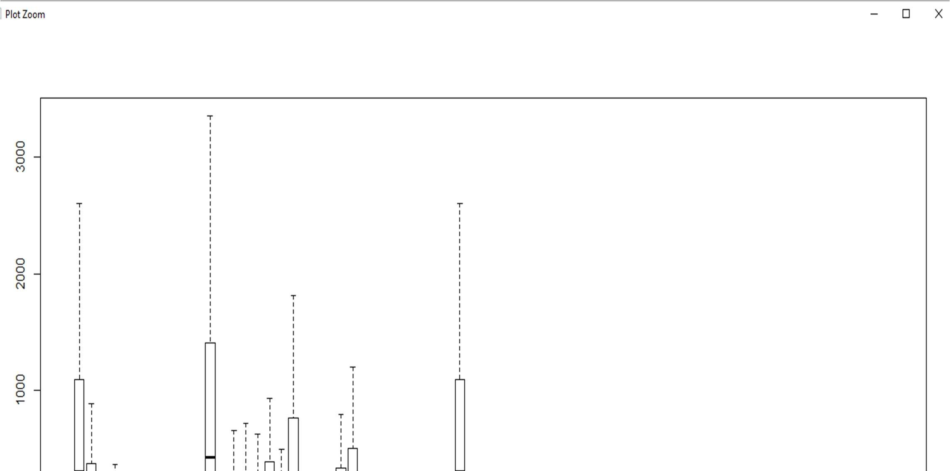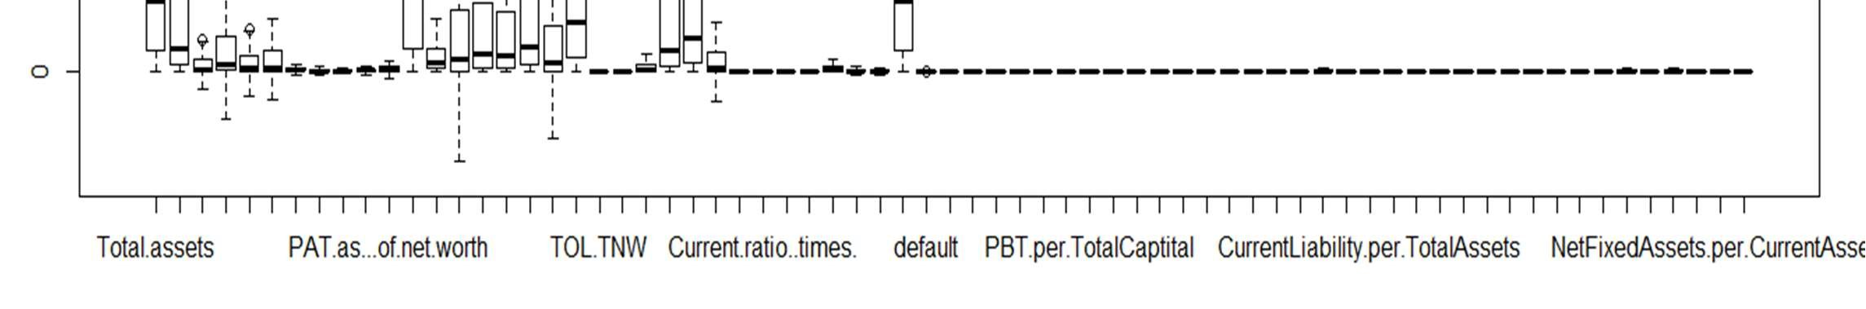

*We can observe that the outliers have been treated well.

## 8. MULTICOLLINEARITY TREATMENT

Multicollinearity occurs when independent variables in a regression model are correlated. This correlation is a problem because independent variables should be independent. If the degree of correlation between variables is high enough, it can cause problems when we fit the model and interpret the results.

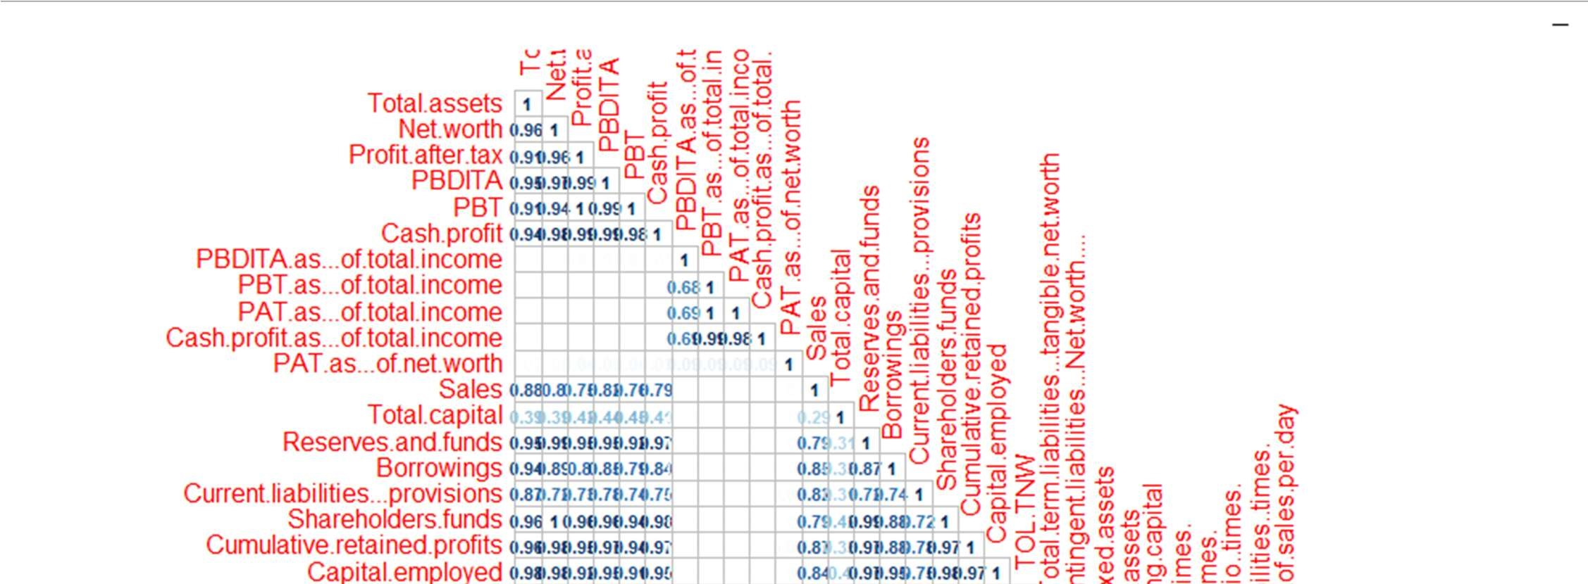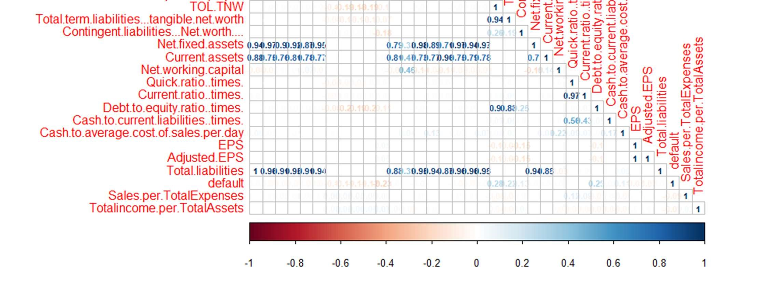

➔ STEPS TO REMOVING MULTICOLLINEARITY IN THIS SITUATION

### 8.1 Creating A Logistic Model

Firstly we will create a regression model so that we can find the Variance Inflation Factor for each of the variables.

m1= glm(dataset1$default~.,data=dataset1,family = binomial())

### 8.2 Using VIF To Remove Highly Correlated Variables

Variance inflation factor (VIF) is the quotient of the variance in a model with multiple terms by the variance of a model with one term alone. It quantifies the severity of multicollinearity in an ordinary least squares regression analysis

Given Below are the variable which we will remove after RECURSIVELY checking the VIF and building the model over again.

|  |
| --- |
| 1. "Total.assets" 2. "Net.worth" 3. "Profit.after.tax" 4. "PBDITA" 5. "PBT" 6. "Cash.profit" 7. "Sales" 8. "Total.capital" 9. "Reserves.and.funds" 10. "Borrowings" 11. "Current.liabilities...provisions" 12. "Shareholders.funds" 13. "Cumulative.retained.profits" 14. "Capital.employed" 15. "EPS" 16. "Adjusted.EPS" 17. "Borrowings.per.TotalLiabilities" 18. "Captialemployed.per.Networth" 19. "PBT.per.TotalCaptital" 20. "ShareholderFunds.per.TotalLiability" [21] "capitalEmp..per.ShareholderFunds"   [22] "NetFixedAssets.per.TotalAssets" |
|  |
|  |

### 8.3 Using StepAIC To Remove The Variables In Such A Way As To Give The Lowest Value Of AIC

Step AIC will build a model for us that is the best i.e., has the lowest AIC value. Therefore, after executing the StepAIC function for our model we’ll get the significant variables which will build the most accurate model for us.

Using the Variables which are shown significant by AIC are used as final variables. We will check for the presence of multicollinearity between those variables.

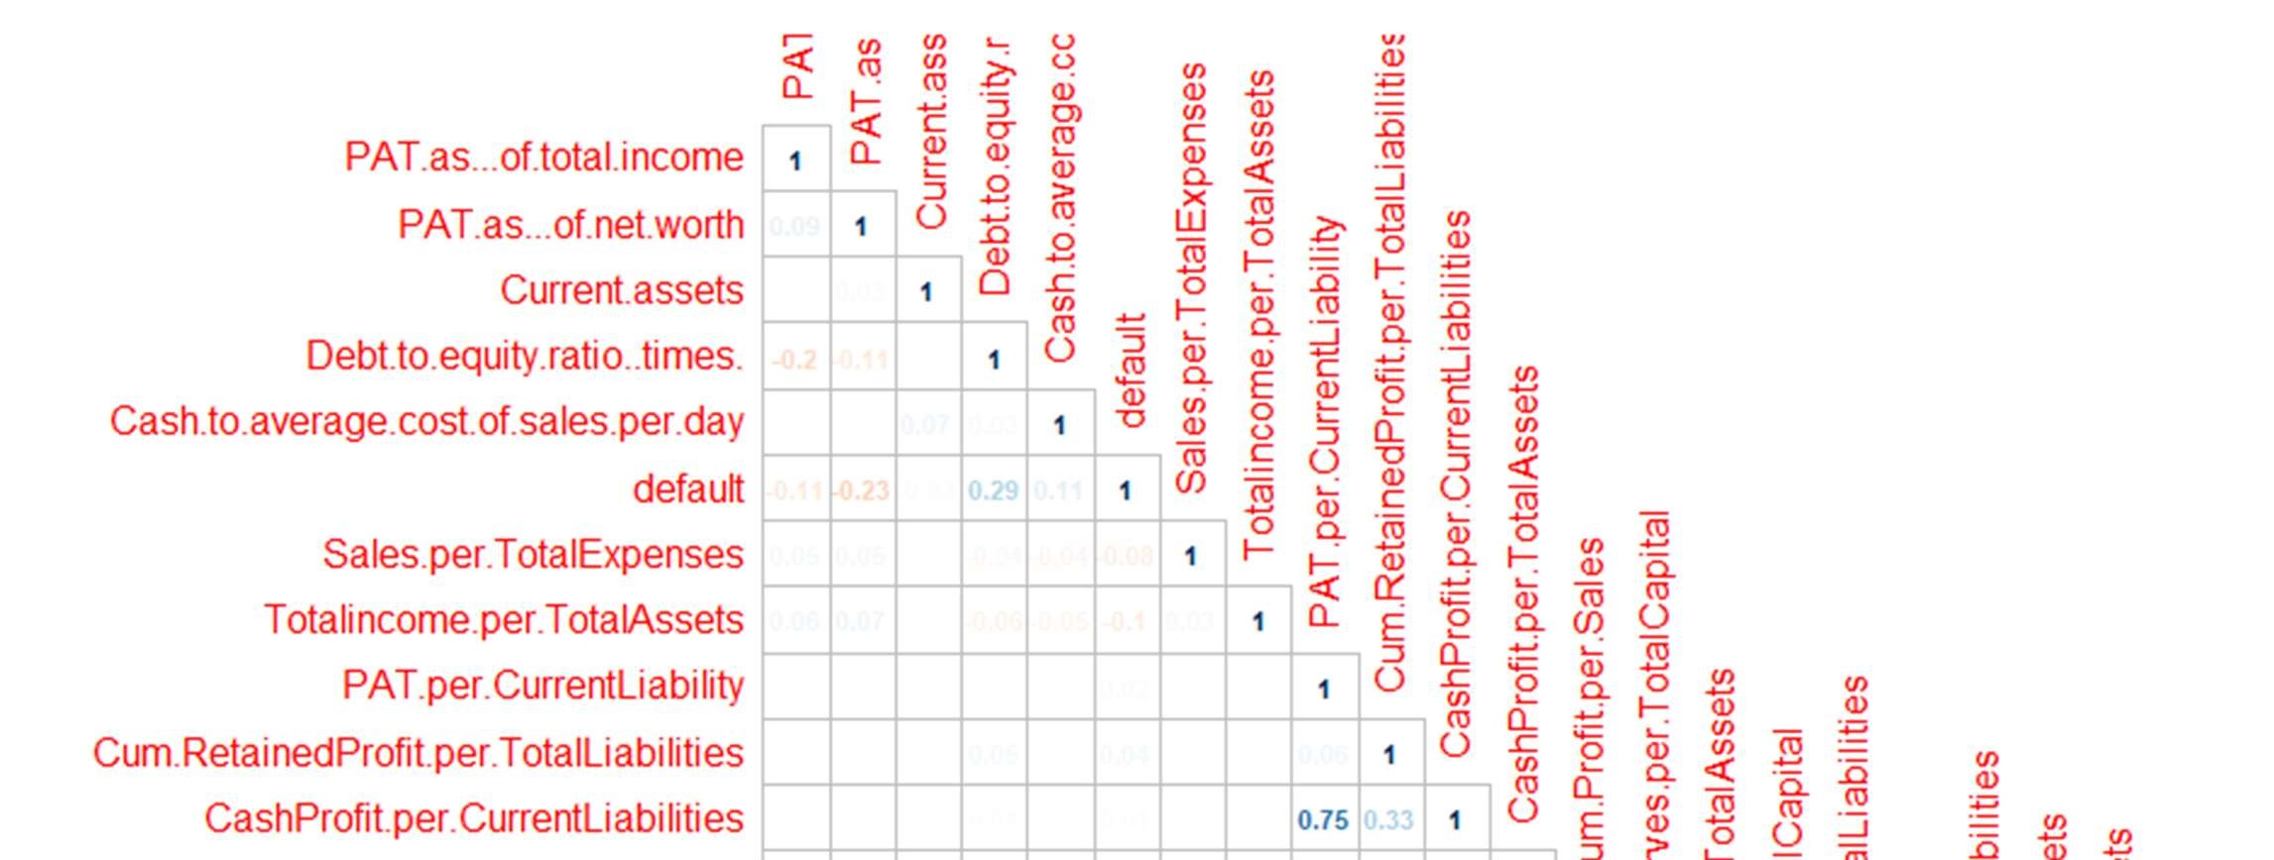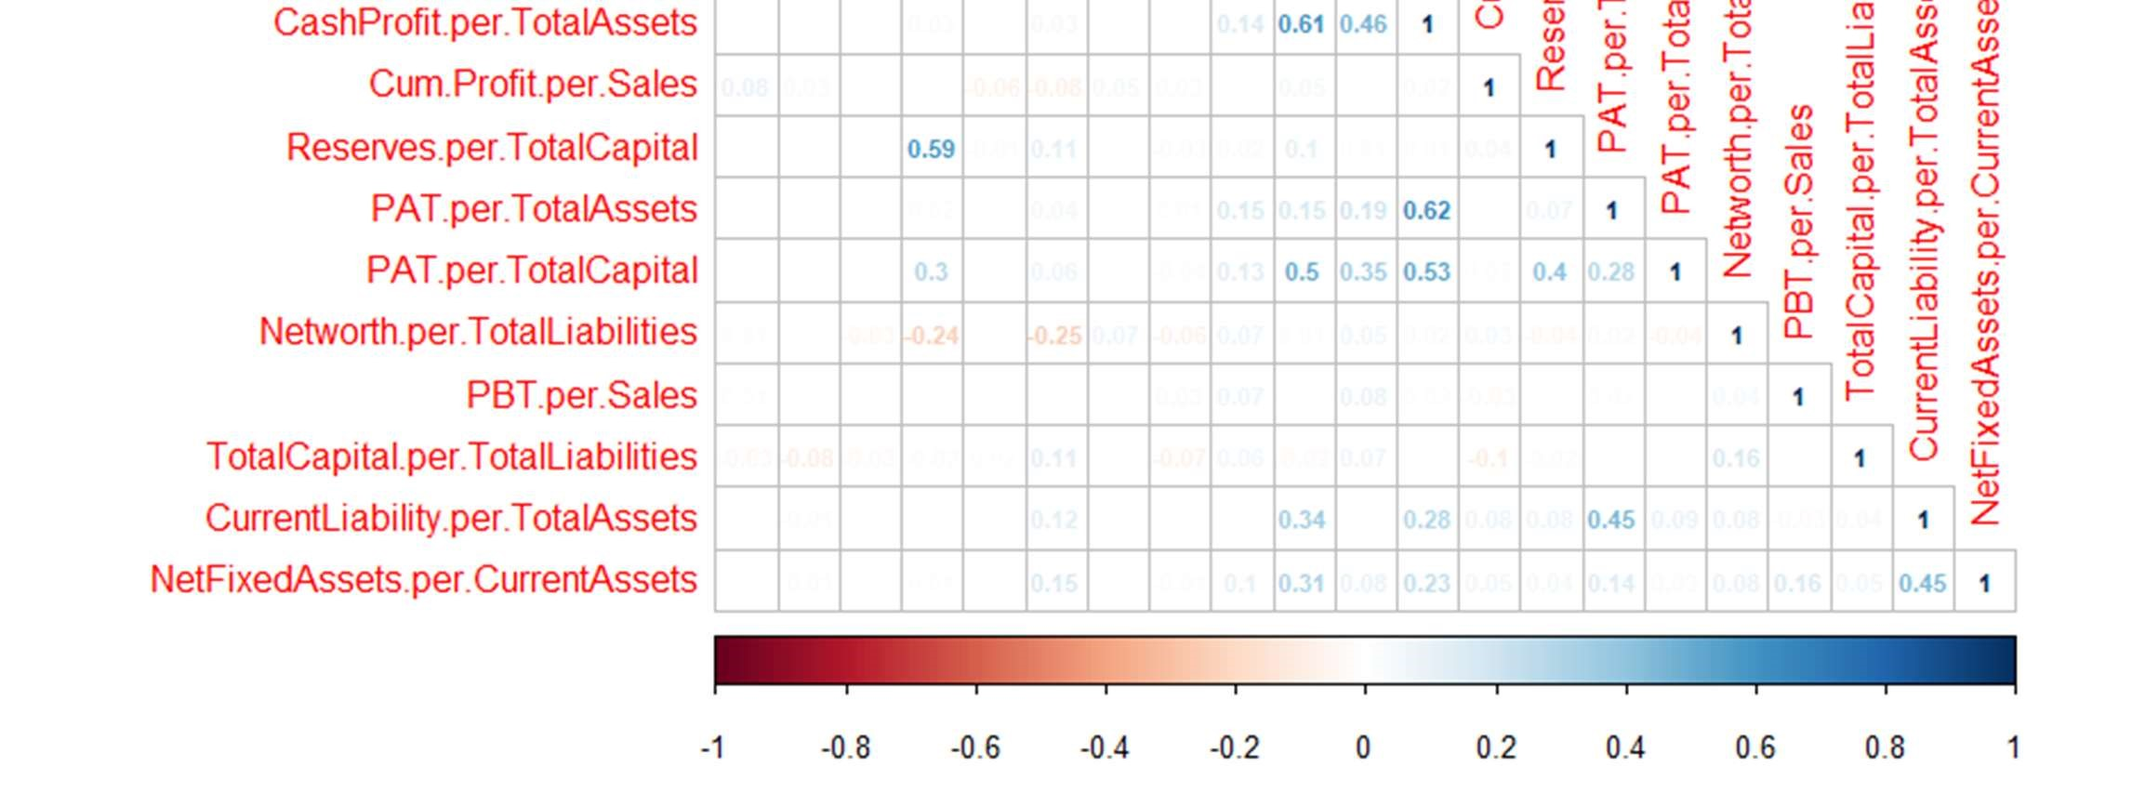

*we can observe that the Multicollinearity has been treated properly.

## 9. SELECTION OF SIGNIFICANT VARIABLES FOR MODEL BUILDING

### 9.1 USING STEPAIC

In stepwise regression, the selection procedure is automatically performed by statistical packages. The criteria for variable selection include adjusted R-square, Akaike information criterion (AIC), Bayesian information criterion (BIC), Mallows's Cp, PRESS, or false discovery rate (1,2). stepAIC(m1,direction = "backward")

train= outdata[,c(9,11,24,28,30,34,35,36,38,44,45,46,47,49, 51,53,54,56,58,61,66)]

Given below are the variables which are significant for our model and are finally selected

|  |
| --- |
| 1. "PAT.as...of.total.income" 2. "PAT.as...of.net.worth" 3. "Current.assets" 4. "Debt.to.equity.ratio..times." 5. "Cash.to.average.cost.of.sales.per.day" 6. "default" 7. "Sales.per.TotalExpenses" 8. "Totalincome.per.TotalAssets" 9. "PAT.per.CurrentLiability" 10. "Cum.RetainedProfit.per.TotalLiabilities" 11. "CashProfit.per.CurrentLiabilities" 12. "CashProfit.per.TotalAssets" 13. "Cum.Profit.per.Sales" 14. "Reserves.per.TotalCapital" 15. "PAT.per.TotalAssets" 16. "PAT.per.TotalCapital" 17. "Networth.per.TotalLiabilities" 18. "PBT.per.Sales" 19. "TotalCapital.per.TotalLiabilities" 20. "CurrentLiability.per.TotalAssets" 21. "NetFixedAssets.per.CurrentAssets" |
|  |
| > |

## 10. BALANCING THE DATASET

The dataset containes the default is unbalanced proportion. The default constitutes only 6.7% of the total dataset . We cannot build a model on this unbalanced dataset. The dependent variable’s proportion in the dataset has to levelled.

### 10.1 SMOTE Method

It is an oversampling technique that generates synthetic samples from the minority class. It is used to obtain a synthetically class-balanced or nearly class-balanced training set, which is then used to train the classifier.

Applying smote on our Final Dataset using Default as an argument so that balancing happens according to the Depemdent variable.

smote.train= SMOTE(train$default~., train)

dim(smote.train)

[1] 1638 21

*Checking the proportion of Default in the Smote Dataset

The dependent variable i.e., is now balanced.

table(smote.train$default)

prop.table(table(smote.train$default))

> table(smote.train$default)

0 1

936 702

> prop.table(table(smote.train$default))

0 1

0.5714286 0.4285714

## 11. CREATING THE FINAL MODEL USING SMOTE DATASET

### 11.1 APPLYING LOGISTIC REGRESSION

Logistic regression is a statistical model that in its basic form uses a logistic function to model a binary dependent variable, although many more complex extensions exist.

In regression analysis, logistic regression (or logit regression) is estimating the parameters of a logistic model (a form of binary regression).

FinalModel= glm(smote.train$default~.,data=smote.train,family = binomial()) summary(FinalModel)

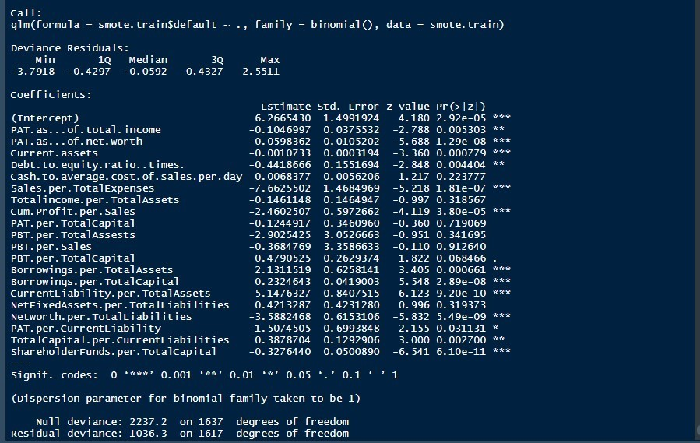

➔ vif(FinalModel)

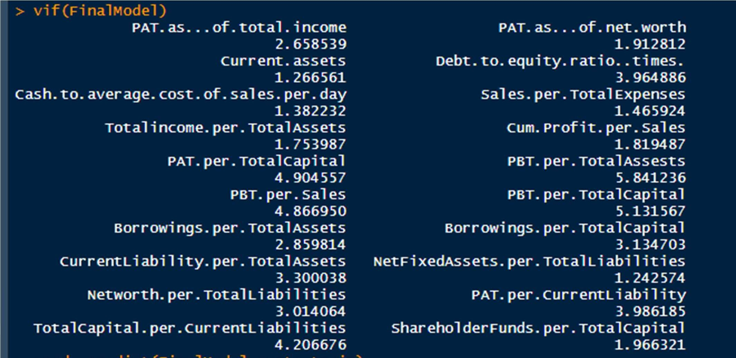

*We can observe that the VIF values are all below 5

## 12. ANALYSIS OF THE COEFFICIENTS OF LOGISTIC MODEL

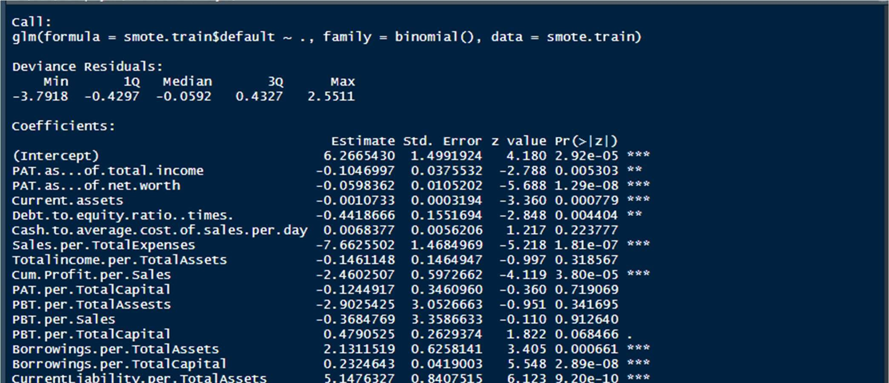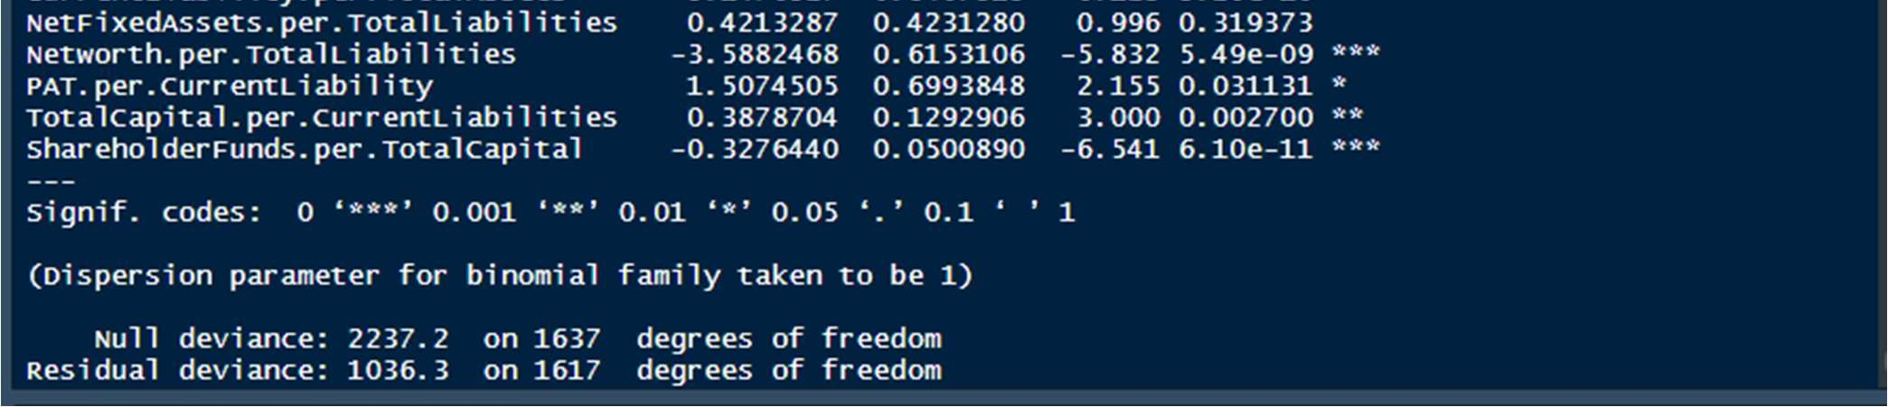

|  |
| --- |
| 0.104 |

1. For every one unit change in PAT as of Total Income, the log odds of Default(versus non-Default) decreases by since there is a –ve sign linked with it.

|  |
| --- |
| 0.059 |

1. For every one unit change in PAT as of Net Worth, the log odds of Default(versus non-Default) decreases by since there is a –ve sign linked with it.

|  |
| --- |
| 0.001 |

1. For every one unit change in Current Assets, the log odds of Default(versus nonDefault) decreases by since there is a –ve sign linked with it.

|  |
| --- |
| 0.441 |

1. For every one unit change in Debt to equity Ratio , the log odds of Default(versus non-Default) decreases by since there is a –ve sign linked with it.

|  |
| --- |
| 0.006 |

1. For every one unit change in Cash to average cost of sale per day, the log odds of Default(versus non-Default) increases by .
2. For every one unit change in Sales per Total Expenses, the log odds of

|  |
| --- |
| 7.662 |

Default(versus non-Default) decreases by since there is a –ve sign linked with it.

1. For every one unit change in Total Income per Total Assets, the log odds of

|  |
| --- |
| 0.146 |

Default(versus non-Default) decreases by since there is a –ve sign linked with it.

|  |
| --- |
| 2.460 |

1. For every one unit change in Cum.Profit per Sales, the log odds of Default(versus non-Default) decreases by since there is a –ve sign linked with it.

|  |
| --- |
| .124 |

1. For every one unit change in PAT per Total Capital, the log odds of Default(versus non-Default) decreases by since there is a –ve sign linked with it.

|  |
| --- |
| 2.902 |

1. For every one unit change in PBT per Total Assets, the log odds of Default(versus non-Default) decreases by since there is a –ve sign linked with it.

|  |
| --- |
| 0.368 |

1. For every one unit change in PBT per Sales, the log odds of Default(versus nonDefault) decreases by since there is a –ve sign linked with it.

|  |
| --- |
| .479 |

1. For every one unit change in PBT per Total Capital, the log odds of Default(versus non-Default) decreases by since there is a –ve sign linked with it.

|  |
| --- |
| 2.131 |

1. For every one unit change in Borrowings per Total assets, the log odds of Default(versus non-Default) increases by .

|  |
| --- |
| 0.232 |

1. For every one unit change in Borrowings per Total Capital, the log odds of Default(versus non-Default) increases by .

|  |
| --- |
| 5.147 |

1. For every one unit change in Current Liability per Total Assets, the log odds of Default(versus non-Default) increases by .

|  |
| --- |
| 0.421 |

1. For every one unit change in Net Fixed Assets per Total Liability, the log odds of Default(versus non-Default) increases by
2. For every one unit change in Net worth per Total Liability, the log odds of

|  |
| --- |
| 3.588 |

Default(versus non-Default) decreases by since there is a –ve sign linked with it.

|  |
| --- |
| 1.507 |

1. For every one unit change in PAT per Current Liability, the log odds of Default(versus non-Default) increases by .

|  |
| --- |
| 0.387 |

1. For every one unit change in Total Capital per Current Liability, the log odds of Default(versus non-Default) increases by .

|  |
| --- |
| .327 |

1. For every one unit change in Shareholder Funds per Total capital, the log odds of Default(versus non-Default) decreases by since there is a –ve sign linked with it.

## 13. PREDICTIONS + CONFUSION MATRIX ON THE DEVELOPED DATASET

pred= predict(FinalModel,smote.train) pred.train= ifelse(pred<0.3,0,1)

# Converting the Default and the pred.train into Factors smote.train$default=as.factor(smote.train$default) pred.train= as.factor(pred.train)

### ➔ Creating a Confusion Matrix for the predictions on the Train Data

caret::confusionMatrix(smote.train$default,pred.train)

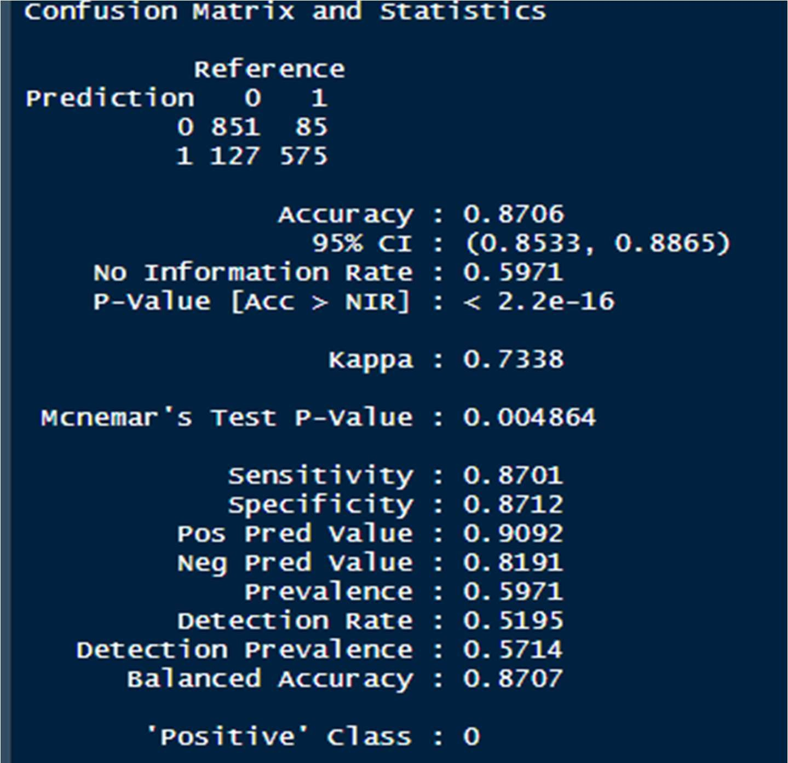

Accuracy : 87.06%

Sensitivity : 87.01%

Specificity : 87.12%

## 14. PREPARING THE VALIDATION DATASET

The validation dataset has to be of the same structure, with the exactly same columns as in the Train dataset.

14.1 Importing the Validation set test= read_xlsx("validation_data.xlsx")

• Removing the basic variables which are majoritarily missing

Because they won’t serve purpose and if we impute them with missing values(through machine learning algorithms) , they would become sort of Artificial Data.

test= test[,-c(1,6,18,19,22,25,32,34,42:48,52)] dim(test)

[1] 715 36

➔ Creating Two new ratios( same as we did for the Raw dataset)

1. Sales.per.TotalExpenses
2. Totalincome.per.TotalAssets

• Removing Total Income and Total expenses ( like we did in Developer Data set)

test=test[,-c(5,4)]

### 14.2 DESCRIPTIVE ANALYSIS

Analysing the validation dataset’s columns. Because these have to be made according to the training dataset. names(test)

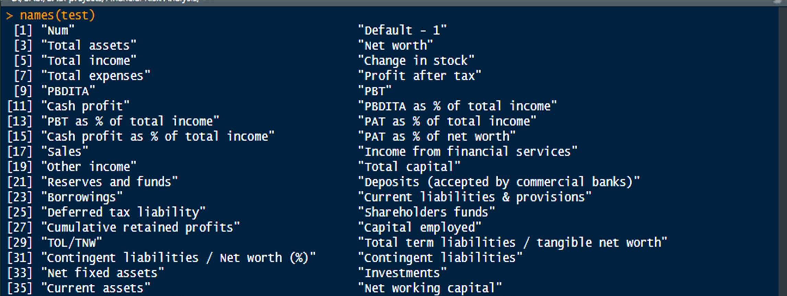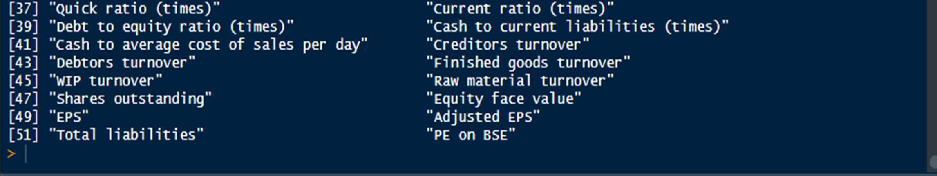

colSums(is.na(test))

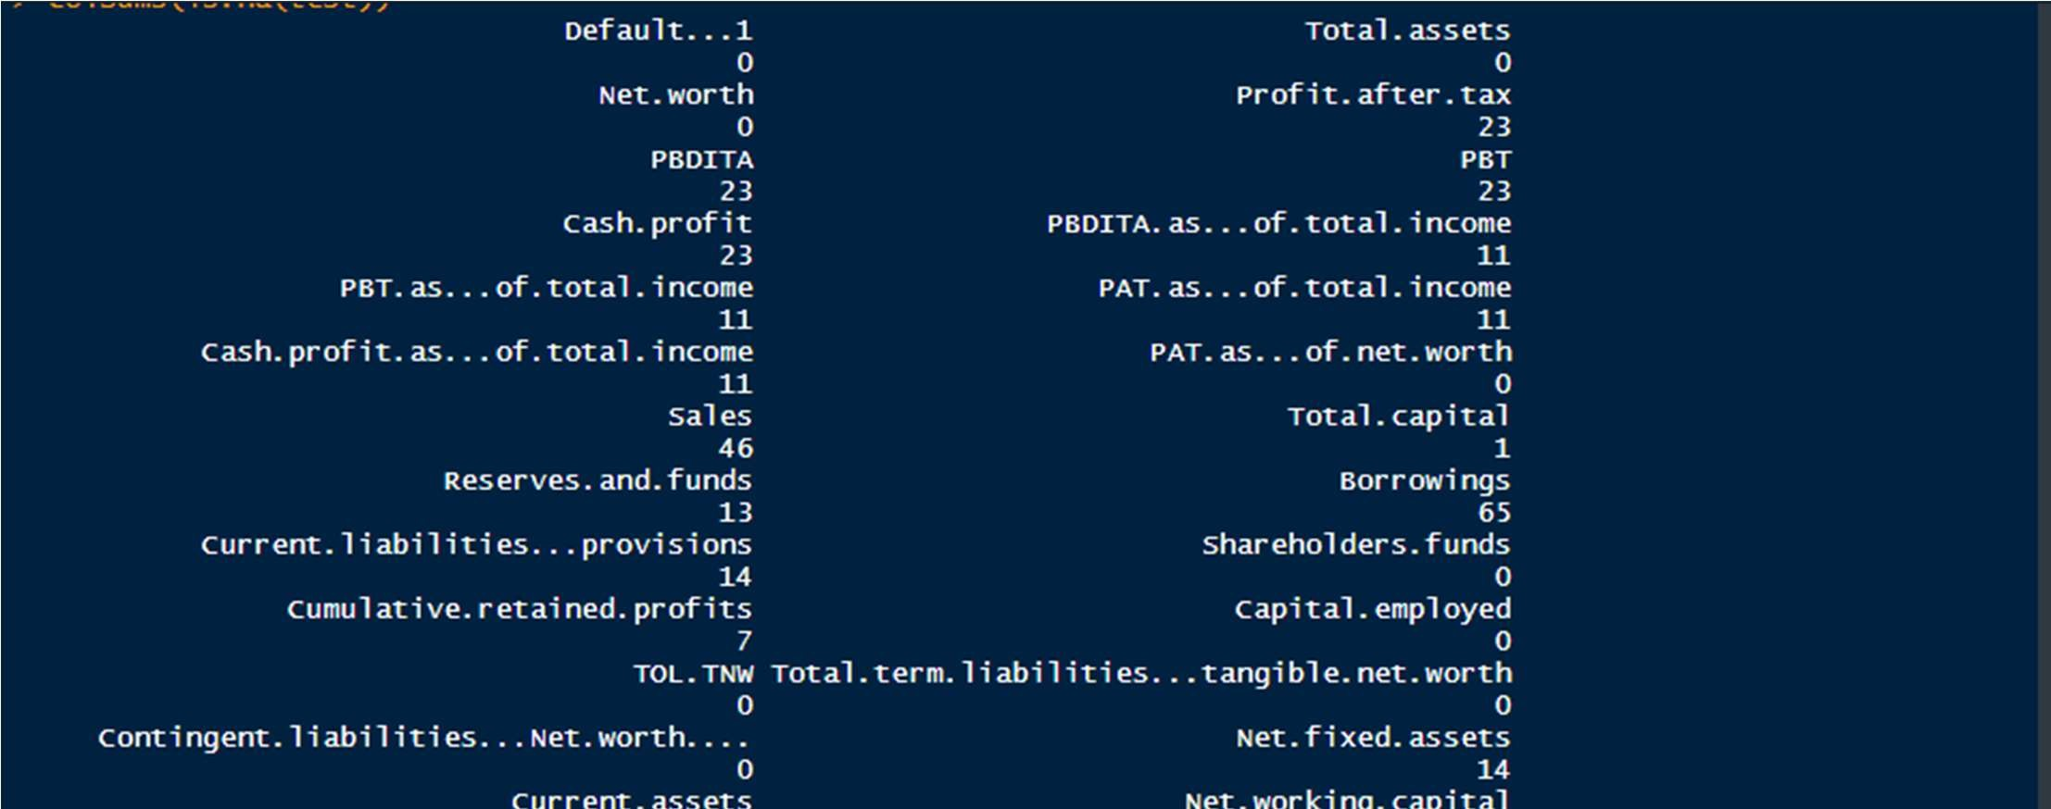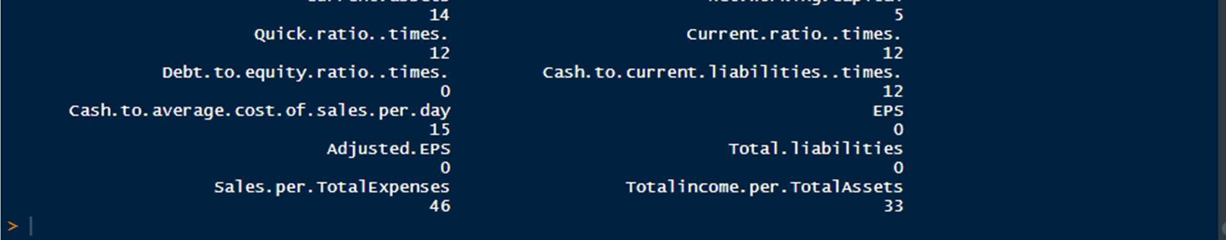

### 14.3 IMPUTING THE MISSING VALUES

There are missing values in our test data set. We are imputing these missing values by MICE machine learning algorithm so as to avoid more missing data after we create ratios from the original variables.

testmice=mice(test,method = "pmm",m=5,maxit=5,seed=8488) test=complete(testmice) anyNA(test)

> False

#### 14.4 CREATION OF NEW RATIOS FOR TEST DATASET(variables same as

TRAIN Dataset)

##### Ratios For Profitability

CashProfit.per.TotalAssets

Cum.Profit.per.Sales

Sales.per.TotalAssets

Sales.per.CurentAssets

PBT.per.TotalCaptital

PAT.per.TotalAssets

PAT.per.Sales

PAT.per.TotalCapital

PAT.per.TotalAssets

PBT.per.TotalAssests

PBT.per.Sales

PBT.per.TotalCapital

PBDITA.per.Sales

##### Ratios For Size

ShareholderFunds.per.TotalAssets

Captialemployed.per.Networth

Reserves.per.TotalCapital

ShareholderFunds.per.TotalLiability ShareholderFunds.per.TotalCapital capitalEmp..per.ShareholderFunds NetFixedAssets.per.CurrentAssets NetFixedAssets.per.TotalAssets

##### Ratios For Leverage

Borrowings.per.TotalAssets

Borrowings.per.TotalLiabilities

Borrowings.per.TotalCapital

CurrentLiability.per.CurrentAssets

CurrentLiability.per.TotalAssets

##### Ratios For Liquidity

NetFixedAssets.per.TotalLiabilities

Cum.RetainedProfits.per.CurrentAssets

Networth.per.TotalLiabilities

Cum.RetainedProfit.per.TotalLiabilitie

PAT.per.CurrentLiability

CashProfit.per.CurrentLiabilities

TotalCapital.per.TotalLiabilities

TotalCapital.per.CurrentLiabilities

### 14.5 SELECTING THE FINAL SIGNIFICANT VARIABLES FOR VALIDATION DATASET

The final variable to be selected in the Validation dataset are those variables which came out as significant variables in out Train Dataset.

We have to make sure the columns of both the TRAIN and the VALIDATION dataset match. There cannot be any discrepancy in that.

Therefore, including the significant final variable into our validation set.

valdata= test[,c(10,12,25,29,31,35,36,38,44,45,46,47,49,51,53,54,56,58,61,66)] names(valdata)

|  |
| --- |
| 1. "PAT.as...of.total.income" 2. "PAT.as...of.net.worth" 3. "Current.assets" 4. "Debt.to.equity.ratio..times." 5. "Cash.to.average.cost.of.sales.per.day" 6. "Sales.per.TotalExpenses" 7. "Totalincome.per.TotalAssets" 8. "PAT.per.CurrentLiability" 9. "Cum.RetainedProfit.per.TotalLiabilities" 10. "CashProfit.per.CurrentLiabilities" 11. "CashProfit.per.TotalAssets" 12. "Cum.Profit.per.Sales" 13. "Reserves.per.TotalCapital" 14. "PAT.per.TotalAssets" 15. "PAT.per.TotalCapital" 16. "Networth.per.TotalLiabilities" 17. "PBT.per.Sales" 18. "TotalCapital.per.TotalLiabilities" 19. "CurrentLiability.per.TotalAssets" 20. "NetFixedAssets.per.CurrentAssets" |
|  |
| > |

➔ Adding Default To Validation Test

valdata$default= as.factor(test$Default...1)

#### *Checking That The Structure Of The Train And The Test Is The Same dim(valdata) dim(smote.train)

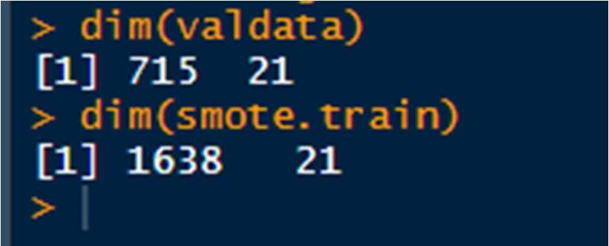

## 15. PREDICTIONS + CONFUSION MATRIX FOR THE VALIDATION DATASET

pred= predict(FinalModel,valdata) predicted= ifelse(pred<0.4,0,1)

### # Converting into factor

predicted=as.factor(predicted) actual= valdata$default

#### ➔ Making a Confusion Matrix for the Validation set

caret::confusionMatrix(predicted,actual,positive='1')

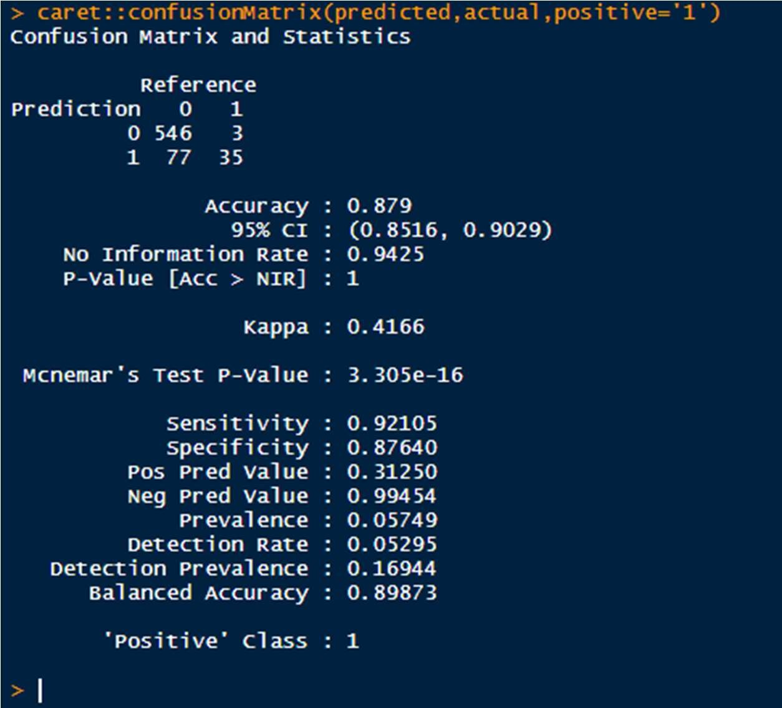

Accuracy : 87.9%

Sensitivity : 92.10%

Specificity : 87.64%

## 16. SORTING AND DECILING OF THE VALIDATION SET

We will group the dataset into 10 groups. In this scenario, the groups will be created based on the Probability of Default that was predicted by our Logistic Regression model.

16.1 ADDING THE PROBABILITY OF DEFAULT IN OUR VALIDATION SET

valdata$Probability.of.Default=pred

16.2 SORTING THE VALIDATION SET IN DESCENDING ORDER BY PROBABILITY OF DEFAULT

valdata=valdata %>% arrange(desc(valdata$Probability.of.Default))

### 16.3 CREATING DECILES

We have two approaches for it here, we will use both.

#### 16.3.1 Making Deciles In The Range Form

probs= seq(0,1 ,length=11) dec= quantile(valdata$Probability.of.Default,probs,na.rm = TRUE) valdata$Deciles= cut(valdata$Probability.of.Default, unique(dec), lowest.include=TRUE,right = FALSE)

tables(valdata$Deciles)

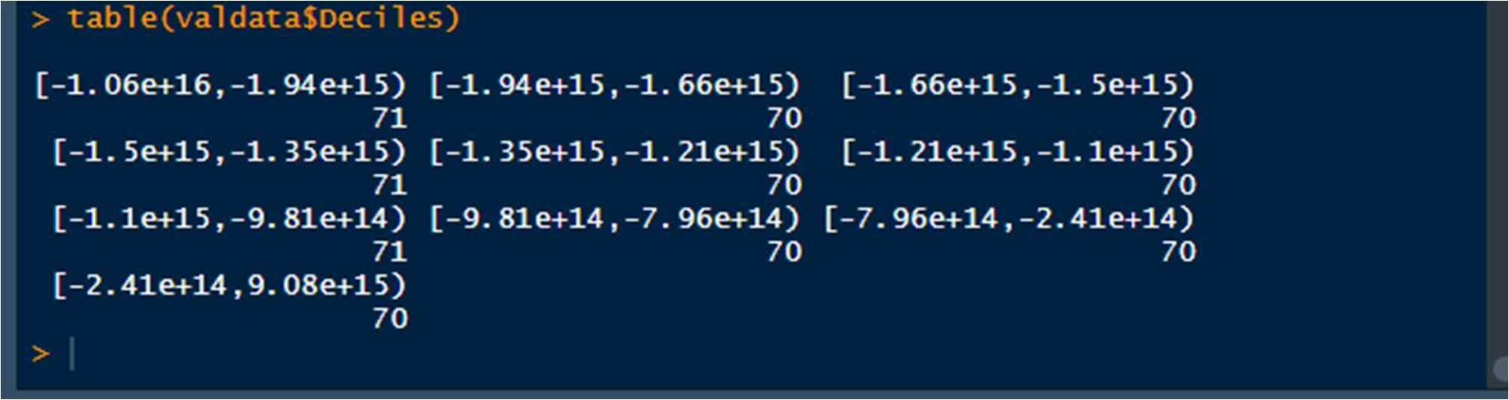

#### 16.3.2 In The Ranking Form

valdata <- valdata %>% mutate(quartile = ntile(-valdata$Probability.of.Default,10))

# Viewing how our Validation Dataset has been divided into 10 Deciles. View(valdata)

valdata$Deciles=valdata$quartile defaulter<- data.table::data.table(valdata) defaulter valdata_decile <- defaulter[,list(`# Defaulter` <- sum(default==1),

Total <-length(default)) , by = Deciles][order(Deciles)]

valdata_decile

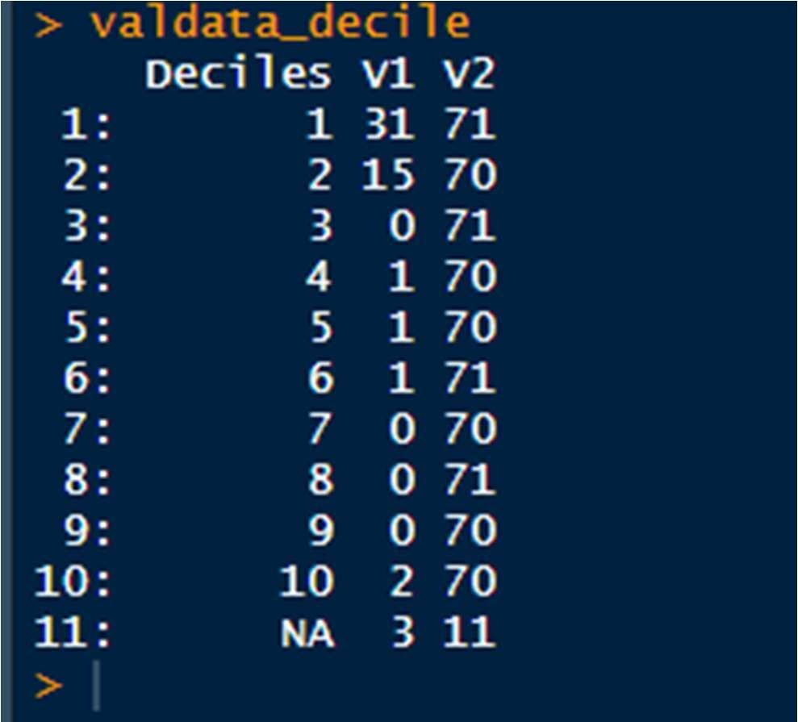

➔ Thus, we have created Deciles , and grouped the validation dataset’s records into 10.

The Column V1 =The number of companies which defaulted (Default=1)

The Column V2= The Total number of companies to which loan was given *Decile 1 has the most number of Defaults